The Seguin Gazette

Seguin volunteers help celebrate 40 years of Ramp Project

Dalondo Moultrie | The Seguin Gazette - December 16, 2025

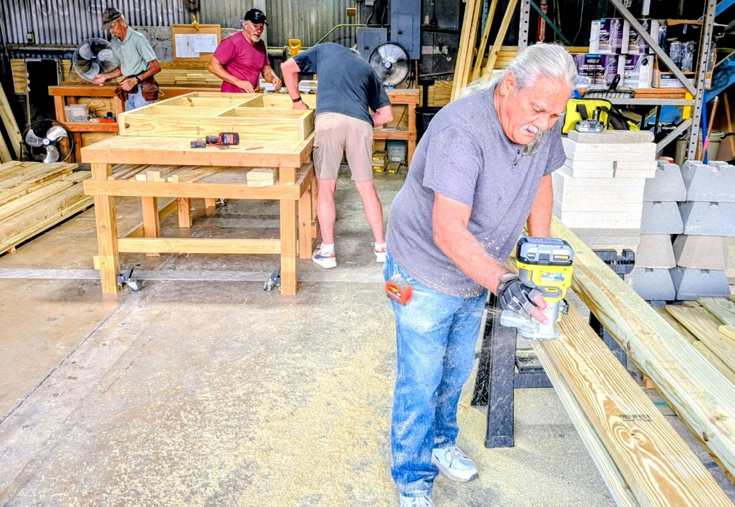
Guadalupe County Texas Ramp Project Volunteer Ken Kaobuilki routers a ramp handrail in preparation for a ramp install recently at the First Methodist Church in Seguin.

For four decades, a statewide nonprofit organization has helped to keep Texans moving, and now it’s time to celebrate.

The Texas Ramp Project is celebrating 40 years of providing freedom and accessibility by constructing ramps that allow people to move around in ways they once couldn’t. While he’s only been at it a fraction of those 40 years, Seguin resident Robin Roark said he sees the value of volunteering with the Texas Ramp Project in Guadalupe County.

“It’s, for me, I enjoy doing things for the community, I enjoy doing things to give back to the community and this is one that’s very rewarding from the standpoint you see an immediate reaction from the family you’re serving,” Roark said. “In the matter of a couple hours, you can dramatically see a change in someone’s life because they have access that they didn’t have before.”

The Texas Ramp Project is a nonprofit organization that provides wheelchair ramps to low-income older adults and people with disabilities identified by local healthcare providers, according to information on the organization’s website.
Volunteers build ramps, which helps keep down costs, it read. The bridges are built without regard to race, religion, ethnicity, age or gender, according to the website.

The website lists some of the Texas Ramp Project’s history.

“In 1985, members of the Kiwanis Club of Richardson, Texas, were asked to build a wheelchair ramp for a friend,” according to the website. “That initial effort, and the next, and the next, resulted in the Dallas Ramp Project and development of a system for providing wheelchair ramps to low-income people with disabilities in Dallas County, at no cost to the recipient.”

Since 2006, the Texas Ramp Project has expanded to 147 Texas counties, including Guadalupe. In September of this year, project volunteers built their 31,000th ramp, which, if laid end to end, would extend over 160 miles, according to the website.

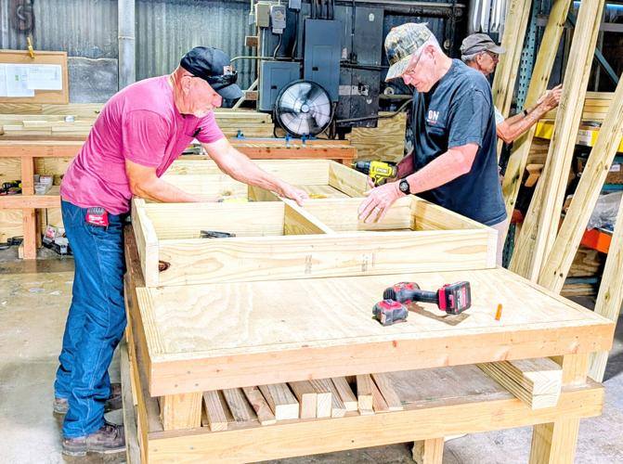
Volunteers with the Texas Ramp Project Robin Roark (left) and Mike Weiss put together a box for decking recently at the First Methodist Church in Seguin.

The work he’s done and seen done since getting involved in 2019 is admirable, Roark said. However, Texas Ramp Project’s use of volunteers and donations help foster another admirable aspect of the organization, he said.

“Texas Ramp Project runs a very lean operation. It’s less than 10% that goes to the administration side of things,” Roark said. “Donations that come in, 90% go back to the community where those donations were made to build ramps right there in your own community.”

People who need the ramps but can’t afford them find themselves in difficult positions, said Barry Jankord, another Guadalupe County Texas Ramp Project volunteer. In the nearly three years he’s participated in ramp operations, Jankord said he’s noticed a great need locally.

“It’s such an important mission here,” he said. “It’s also the time of year people are saying, ‘hey, I’m not sure what to donate to.’ This is something they can donate to and it’s going to a worthwhile effort in Seguin.”

The best way to learn more or donate is to visit texasramp.org and get involved, Jankord said.

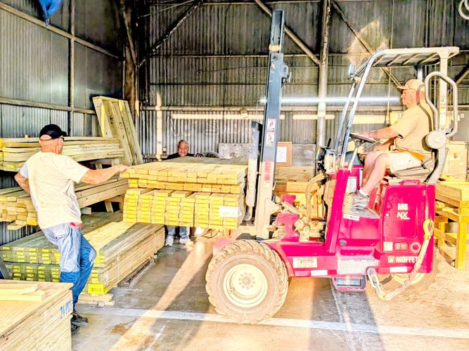
Volunteers unload lumber to help the nonprofit efforts of the Texas Ramp Project at the First Methodist Church in Seguin.

