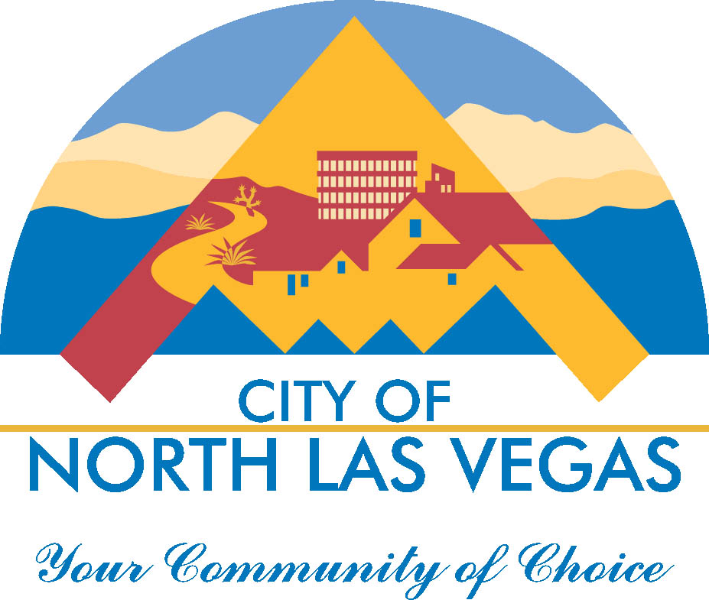
Mayor City Manager

John J. Lee Ryann Juden

Council Members
Isaac E. Barron
Pamela A. Goynes-Brown
Scott Black
Richard J. Cherchio

Land Development & Community Services
Marc Jordan, Director
Building & Fire Safety Division
2250 Las Vegas Boulevard, North · Suite #125 · North Las Vegas, Nevada 89030
Telephone: (702) 633-1577 Fax: (702) 649-9643 · TDD: (800) 326-6868
www.cityofnorthlasvegas.com

Industry Notice
Re: COVID-19

Effective immediately all inspections from Building and Fire Safety shall be done via video and/or photo means. There will not be any inspections performed in person. Any inspections in person must be pre-authorized by City Management. Each Inspector shall guide the process of the inspection. Any video means available will be permitted. Photo means shall require enough photos to perform the complete inspections.

Any projects that have concern from inspections and/or industry shall be identified and reevaluated at a later date.

Permit application shall be allowed via electronic processes and drop-off and pick-up at the front door of City of North Las Vegas City Hall at 2250 N Las Vegas Blvd.

Any format of electronic submittal will be allowed during this time, i.e. PDF format, Blue Beam, jpeg, etc. All rules from the Nevada State Board of Engineers and Land Surveyors, The State Architect’s Board, The Nevada State Contractor’s Board, and the City of North Las Vegas ordinances and adopted codes shall be strictly adhered to.

The City of North Las Vegas Building and Fire Safety Division will utilize any means possible and accepted by the Building Official to continue to allow the development process.

Please be aware that as we transition the way we currently do inspections there will be challenges and delays. Please understand that the Building and Fire Safety Division of Land Development and Community Services is addressing each challenge as it arises and finding solutions as swiftly as possible.

Contact Information:

Building Support Staff: For inspections, records, research, online portal access, etc.

buildingsafetyinquiries@cityofnorthlasvegas.com
Building Support Specialists: (702) 633-1577, (702) 633-1578
Inspection Line: (702) 633-1576
Fire Safety: (702) 633-2616

Permit Application Center (PAC) and Plan Review:

buildingpermits@cityofnorthlasvegas.com
PAC: (702) 633-1536
Plan Review: (702) 633-1550

Specific questions can be directed to Valarie Evans Building Official M.C.P.

Valarie Evans M.C.P.
Building Official
Land Development and Community Services
Building and Fire Safety
City of North Las Vegas
2250 Las Vegas Blvd. North
North Las Vegas, NV. 89130
702-633-1580 O
702-239-4071 C

