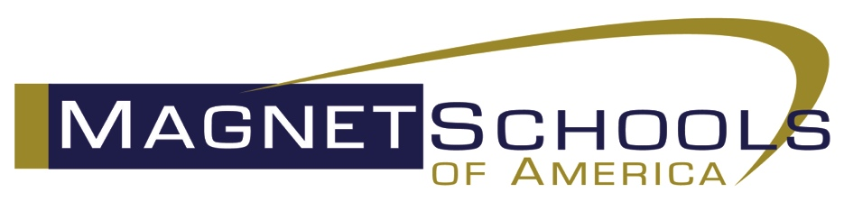

Notice of Open Board Positions

Open Board Positions: Magnet Schools of America (MSA) is accepting applications and letters of interest for election to the Board of Directors for 2019-2021. The open positions include:

- Secretary
- Treasurer
Interested candidates must be members of MSA and are requested to submit the required materials below to Todd S. Mann, Executive Director, Magnet Schools of America by Monday, January 14, 2019, 5pm EASTERN. All materials submitted will be published on the MSA website.

- Letter of interest for the position;
- One-page resume/vitae;
- 50-word statement indicating why you should be elected to the position;
- Picture (head shot), color preferred;
- Be available for a 20-minute rehearsal on Thursday, January 17, 2019 at 11am EASTERN
- Present their interest on a webinar on Thursday, January 17, 2019; those for Secretary at 2pm EASTERN and those for Treasurer at 3pm EASTERN.

Voting, which is done by online ballot, will commence on Friday, January 18, 2019 and end at 5pm EASTERN on Friday, February 1, 2019.

Board members are required to attend three (3) meetings each year, held in conjunction with conferences: one in the fall with Technical Assistance and Training, one in the winter with Policy Training, and one with the National Conference on Magnet Schools. Board members are encouraged to attend each conference, particularly the National Conference and the MSA Business Meeting. Board members are reimbursed for the Board meeting only portion of their travel, and as follows: if they have paid more than 50% of meeting costs from personal funds (that are not otherwise reimbursed), they will be reimbursed by MSA up to $1,000 of the personal funds.

The Secretary and Treasurer positions are members of the MSA Executive Committee. The Executive Committee meets virtually every month for one hour. Participation is part of the role of each Executive Committee member. Meetings are typically the 3rd Monday of every month in the morning.

Additional questions, please email Ashley Rubenstein at ashley.rubenstein@magnet.edu.

Position Descriptions

SECRETARY
The Secretary shall keep accurate records and reports of the meetings of the Board of Directors, and the Annual Business Meeting; he/she shall have charge of all committee reports submitted for the record.

Time & Commitment
The Secretary is a member of the Executive Committee and attends the in-person Executive Committee meeting which is held prior to each board meeting. The Secretary also attends the monthly virtual meetings of the Executive Committee. In addition, the Secretary is required to attend all Board meetings, including: National Conference (April/May), Fall Technical Assistance (October/November), and Policy Conference (February). Board members are reimbursed for the Board meeting only portion of their travel, and as follows: if they have paid more than 50% of meeting costs from personal funds (that are not otherwise reimbursed), they will be reimbursed by MSA up to $1,000 of the personal funds.

TREASURER
The Treasurer shall report all dues and other monies to which the association is entitled as well as financial data as appropriate to all meetings of the Board of Directors including the members at the Annual Business Meeting, based on financial reports submitted by the Executive Director of Magnet Schools of America, Inc. He/she may co-sign checks with the Executive Director in accordance with policy established by the Executive Committee, and prepare the annual budget in cooperation with the Executive Director and the Executive Committee.

Time & Commitment
The Treasurer is a member of the Executive Committee and attends the in-person Executive Committee meeting which is held prior to each board meeting. The Treasurer also attends the monthly virtual meetings of the Executive Committee. In addition, the Treasurer is required to attend all Board meetings, including: National Conference (April/May), Fall Technical Assistance (October/November), and Policy Conference (February). Board members are reimbursed for the Board meeting only portion of their travel, and as follows: if they have paid more than 50% of meeting costs from personal funds (that are not otherwise reimbursed), they will be reimbursed by MSA up to $1,000 of the personal funds.

