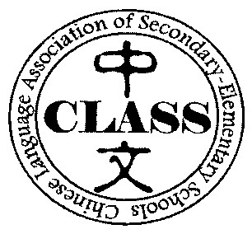
全美中小学中文教师协会
Chinese Language Association of Secondary-Elementary Schools
National Chinese Honor Society (NCHS)
CLASS
美国高中中文荣誉学会学生申请表

Student Application Form

NCHS membership fee is $5 for each new inductee. Student application form should be submitted directly to the advisor/ the Chinese teacher at your local school chapter of the Chinese Honor Society. The deadline is Sunday, December 6th, 2020.Here is a link to turn in your applications: https://classroom.google.com/w/MjE4NjcxNDUxMzIw/tc/MjI4OTMwMTkwNjkz
Class code: 3r7rgan

1.姓名（中文）_______________________ 姓名（英文）__________________________________

2.出生日期﹕_____________年____________月____________日 年龄/年齡﹕_________________

3.住址﹕_________________________________________________ 性別﹕ 男 / 女

4.电邮 / 電郵﹕（大写）_______________________________________________________________________
5. 电话/電話：

6. 学校 /學校﹕______________________________________年級﹕___________________________

7.中文一成績 ___________ | 中文 二成績 __________ 中文三成績 _____________
中文四成績 ____________ | 中文五成績 __________ 其他中文课成績_________
8. Grade 9 GPA ______ | Grade 10 GPA ____ Grade 11 GPA

9.List any extra-curricular school activities, clubs, and organizations to which you belong, and years belonged.

10.List any positions of responsibility and/or offices held at your high school.

11.List any community service you have performed in the last three years.

12.Write a brief reflection in 250 words or less on your learning experience in Chinese classes.

