A CALL TO ACTION BEYOND THE BOARDROOM

Executive Institute on Inclusion (EII): A Unique DEI Program Focused on Systemic Change

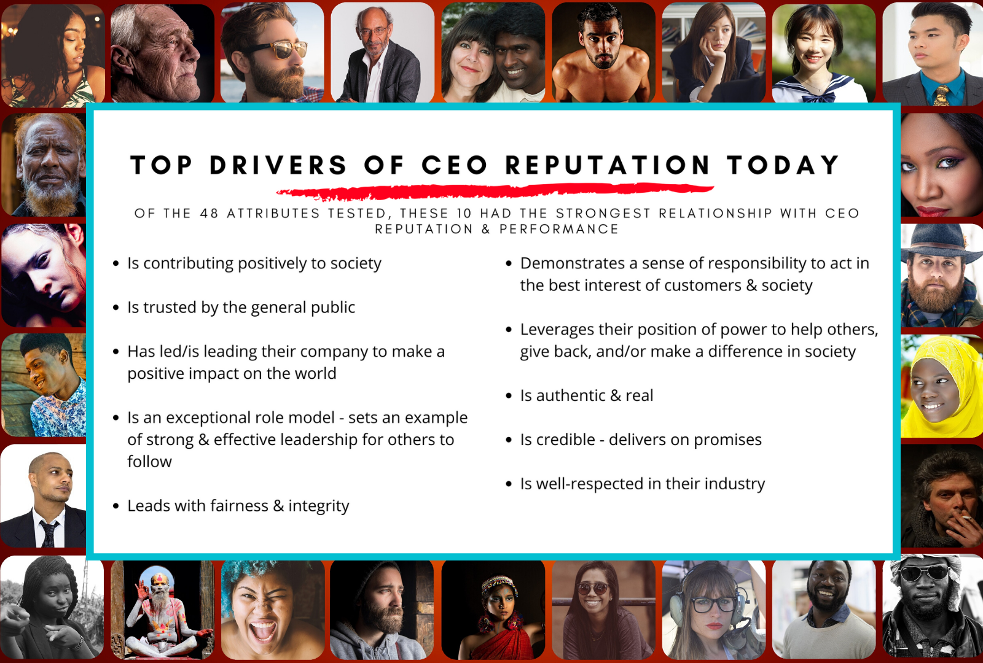
As challenges permeate organizations, oftentimes companies miss the mark on developing a comprehensive plan to shift culture, create awareness, develop their organization, and properly position themselves for growth. It’s critical that leadership becomes serious about DEI. This multi-month, multi-level program provides the 3 M’s: messages, measurements and meaningful tools, that create change, improve company culture, and ultimately grow the bottom line.
The Executive Institute on Inclusion (EII) is a program where corporate America works together with our faculty and channel partners to achieve equity and advance opportunities for all. All across the country, companies that engage with the EII will:
- Make a commitment to achieve fair practices and equity;
- Focus on the power of their own institutions’ policies, practices, pay and pipeline; and
- Work in partnership with the EII to create and implement sustainable plans.

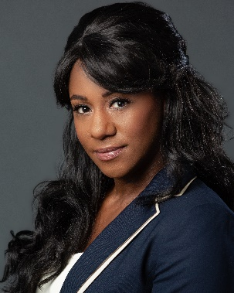 | Contact:  Tiffany Archer  Faculty Member, Executive Institute on Inclusion  e: tiffany.archer@gmail.com | w: Executive Institute On Inclusion

