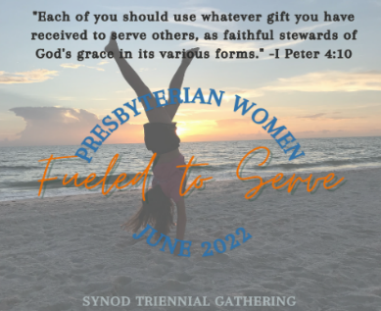
Welcome!

On June 24-5, 2022, women in Presbyterian churches throughout the Synod of Living Waters will be gathering virtually for our Triennial Gathering. This is a new experience and a not so new experience. Your Gathering Planning Team has been meeting for the past 20 months and praying that we would be able to gather in person. As of August 2021, we secured lodgings, the Independent Presbyterian Church Birmingham as our host church, and some “field/mission” trips. In addition to program planning, we were making plans for electronic payments for registration fees and purchases from the gift shop. We also continued plans for an in-person meeting and to make deposits.
We met in January 2022 to continue to firm up plans just before the second installment for the lodging commitment was due. However, with much discussion, the Planning Team unanimously voted to recommend that we go to a virtual meeting. The whole CT then met a week later and again discussed in depth the pros and cons of holding an in-person meeting. The CT voted unanimously to go virtual. If you have any questions about the how and why the decision was made, please do not hesitate to contact me, and I will do my best to answer your questions.

Almost all presenters were willing to engage with you by Zoom. Our efforts for electronic payments plans have now evolved into an online registration and payment process. The link to register online is: www.pwsynodlw.com. If you have difficulty using the site, submit your questions via the “Questions” tab on the website, or send an email to pwsynodlw@gmail.com You may register online up to June 20, 2022. There is a single registration fee of $50.00 that includes both days. You can also register the traditional way using the included paper registration form. Please make sure you get your paper registration and check in by June 1, 2022, so that you will receive the Zoom links. Make a copy for yourself. Mail your completed form and check to:
Judy Persons
500 E. Rose Street
Jackson AL 36545

Our brief Business Meeting will immediately follow Carol Bechtel’s presentation on June 25, 2022. You will be introduced to the new Coordinating Team 2022-2025. Susan Jackson Dowd will install the CT members.

One advantage to a virtual gathering is the opportunity for more people to participate since traveling time is greatly reduced. Once you have registered, you may invite your friend or friends to join you as you meet Carol Bechtel, the author of the 2022-2023 Horizons Bible Study, and other presenters who will help you be Fueled to Serve. If your church has the capability to connect a computer to a big screen, you can gather with other women in the church for the workshops and enjoy a brown bag lunch together.

In Christ’s Service,
Jan Albert, PW Moderator for the Synod of Living Waters


