Contemplative Outreach Birmingham
in partnership with
The Commission on Spirituality of the Episcopal Diocese of Alabama and
Metagem Institute
present
“Becoming Prayer: Incarnation Makes Mystics of Us All”
The Rev. Dr. Vincent Pizzuto, Presenter
Saturday, March 12, 2022
St. Stephen’s Episcopal Church, Birmingham, AL
9:00 am - 3:00 pm
Concludes with a Celtic Contemplative Eucharist

“The universe is not merely a backdrop for the story of human salvation but is its object. Creation, incarnation, and deification are three inseparable moments in one continuous story of salvation. In other words, incarnation and deification are built in to the very plan of creation and bring it to its perfection. While the cross of the redeemer may well be the consequence of a fallen world, the singular catalyst for the incarnation is a love unrestrained and ‘hidden for ages in God who created all things’ (Eph 3:9).”
-Fr. Vincent Pizzuto, Contemplating Christ: The Gospels and the Interior Life, p. 37

Fr. Vincent Pizzuto, Ph.D.
Professional Bio and Links to Resources
Father Vincent Pizzuto, Ph.D. is Professor of New Testament Studies and Christian Mysticism in the Department of Theology and Religious Studies at the (Jesuit) University of San Francisco. As an Episcopal priest Vincent also serves as Vicar of St. Columba’s Episcopal Church and Retreat House in Inverness, California. Working for the advancement of contemplative Christianity, he has reinvigorated the mission and ministry of St. Columba’s through the introduction of contemplative eucharistic liturgies, public lectures, online courses, directed retreats, thought provoking sermons, an online blog and a weekly online study of his book through the Peace Chapel. Entitled Contemplating Christ: The Gospels and the Interior Life, his book seeks to bring his readers into a lived realization of the Christian doctrine of deification – that is, the affirmation that through the Incarnation, we have all been made partakers of the Divine Nature.
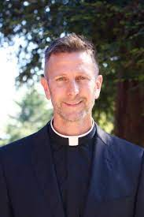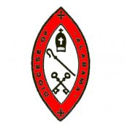

Pre-Registration $60/At the Door (cash or check) $75
Registration Link: https://bit.ly/BecomingPrayerMarch12

