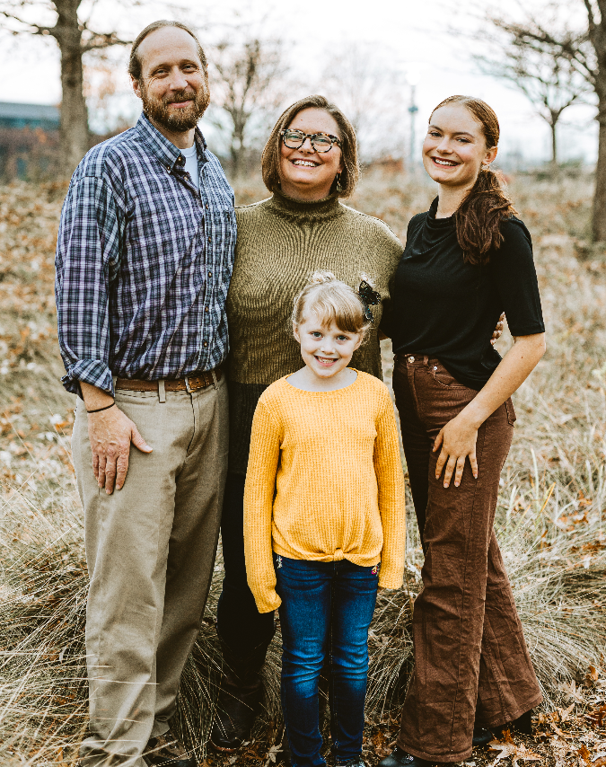
To serve “A Home in the Heart of the City” Nicole Newton and her family move to the country

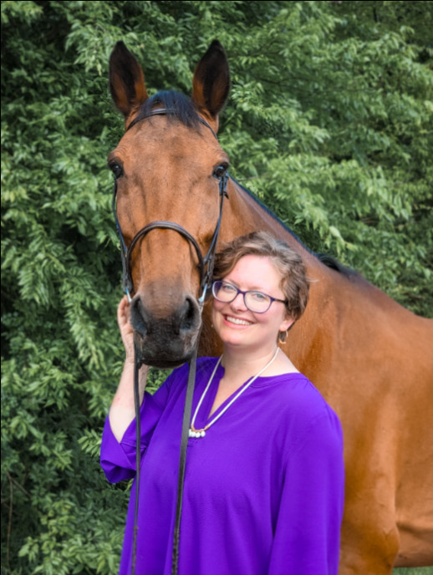
To serve “a home in the heart of the city” Nicole Newton, new associate pastor at First PC/Birmingham, has moved to the country. Nicole and her family which includes husband Jonathan, daughters Alecia (17) Lena (8), an aging Golden Retriever, and three cats have spread out on one acre of land on the banks of the Little Cahaba River in Leeds (chicken coops to be ready by fall). Just eight miles away, roaming pasture land in Moody, is the family’s horse, Tom, a rescued harness racer, and their pony, Harry.
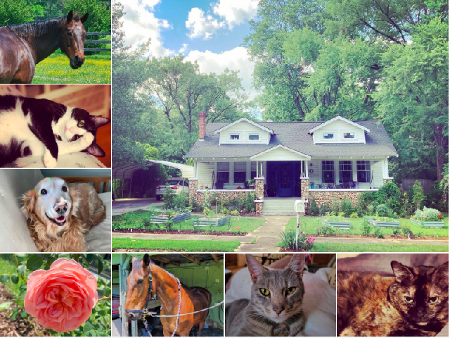
Nicole, reared in rural North Carolina, was an English teacher before she experienced the call to ministry. She received her MDiv at the Wake Forest University Divinity School and an MA in Christian Education from Union Seminary’s Charlotte campus. Nicole was ordained in 2019 at First PC, Wilmington, NC, where she served as associate pastor for children and youth.
She says she was drawn to Birmingham by FPC’s the social justice ministry and by the city’s “close proximity to my elderly father and two of my sisters, plus the funky vibe of the town.”
Husband Jonathan was also an English teacher, but now “splits his time between working at the Library in the Forest in Vestavia and for the Birmingham Barons.” Daughter Alecia is headed to Mississippi State this fall to study forestry and wildlife, while sister Lena will be entering the third grade.
In her spare time Nicole loves to cook, travel, grow flowers, and read. Plus, she will soon be certified for trauma-Informed equine rescue. Husband Jonathan spends his spare time in their garden and playing music.

