Press contact: Ralls Coston, Mission Coordinator
Presbytery of Sheppards and Lapsley
3603 Lorna Ridge Rd., Hoover, AL 35216, rcoston@pslpcusa.org, Cell: 205-617-0216

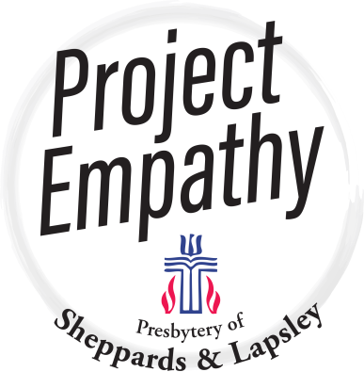

Project Empathy Has Been Completed!
Project Empathy, a project of the churches in the Presbytery of Sheppards and Lapsley, Presbyterian Church USA , has completed its goal of raising money to eliminate medical debt in the Black Belt.
The Presbytery, in partnership with RIP Medical Debt, Inc., a 501(c)(3) non-profit (website: ripmedicaldebt.org), set a goal to raise $50,000 to eliminate $5 million of debt in ten counties in the Black Belt. In fact, we raised a total of $96,859.98! This was completed by March, 2021. However, much of the medical debt in the Black Belt became unavailable for purchase. RIP Medical Debt worked to find more debt in the original ten counties and twelve more counties in south central Alabama. Also, RIP Medical Debt was able to purchase debt from an Alabama hospital which treats patients from across Alabama. In this manner, we were able to purchase and eliminate $10,292,875.15 of debt, affecting 9,071 people in 23 counties in Alabama.
RIP Medical Debt buys debt with the donations and forgives the debts, sending letters to the debtors and to credit reporting agencies, notifying them that the debts are no longer owed.
The idea for Project Empathy came from a Sunday School class at Southminster Presbyterian Church. They brought the idea to the Presbytery’s Executive Council in March, 2020. The Council approved the Project and we got to work, planning and promoting the Project.
We are grateful to all the churches, foundations and individuals who gave so generously to help others. And, we are grateful to God for enabling us and guiding all people involved in doing this Project.
The next page shows RIP Medical Debt’s Project Empathy Medical Debt Fulfillment Report.

