In recent weeks, we have received several new families into our Secured Dwellings Program for homeless boys and girls along with their mothers or grandmothers! Each individual made in the image of Almighty God with immeasurable value and great purpose – now at a place of healing on a path of hope as we approach 155 years of serving children and families in need. We are excited to celebrate Christmas with all of our residents on campus with gifts, food, and fellowship!
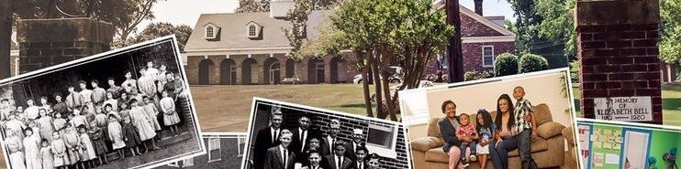
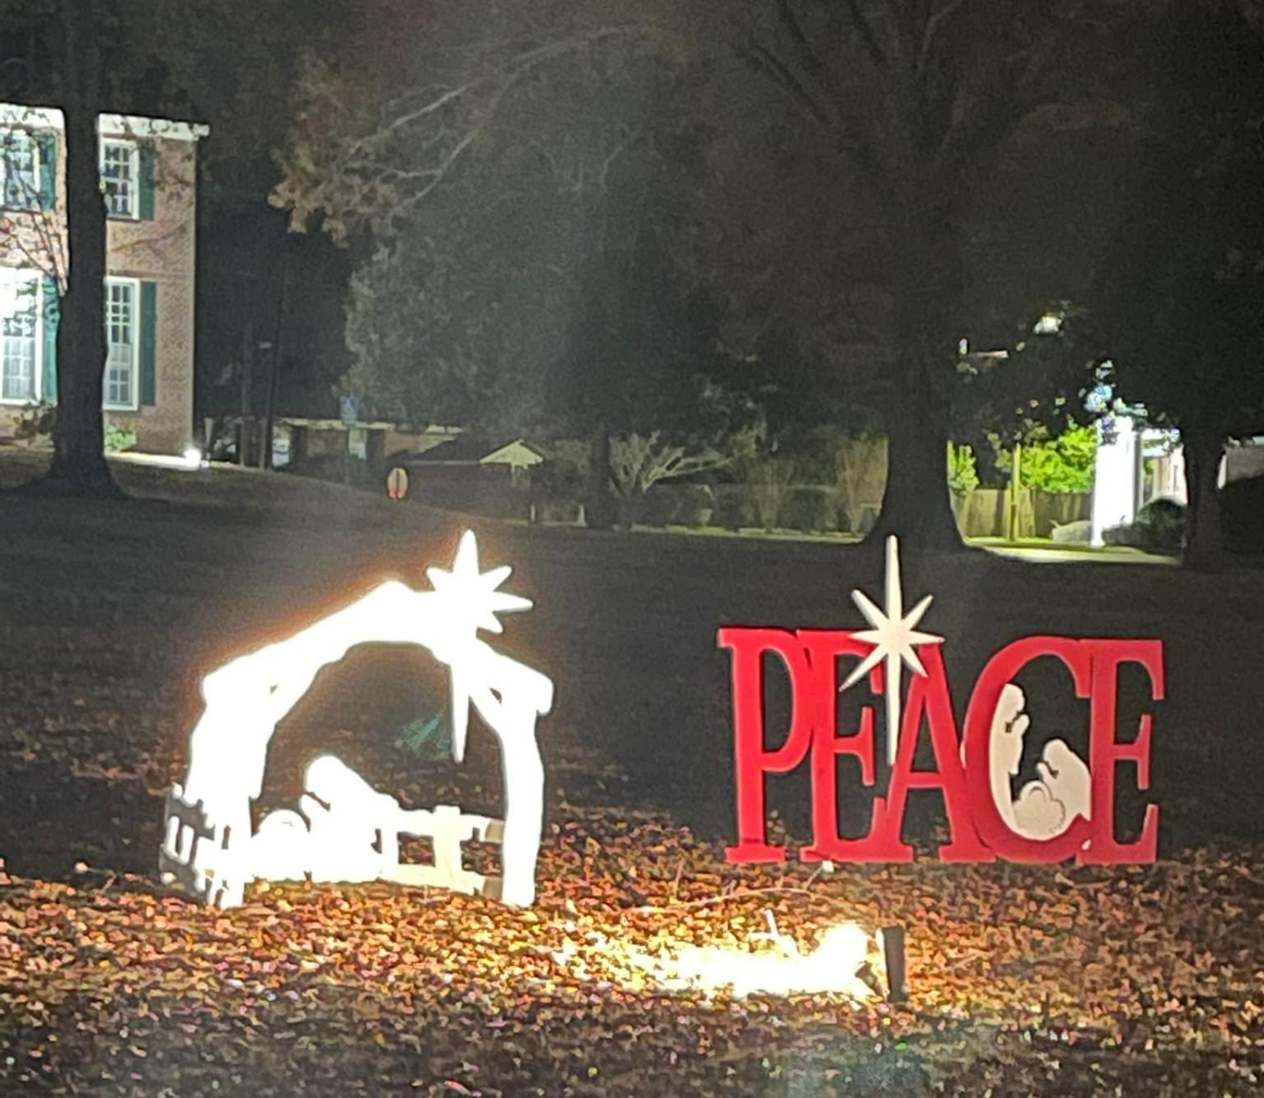

What a blessing for all of us at the Presbyterian Home for Children to partner with “Mae Mae’s Hugs” in loving memory of Haley Maegan Moore, Vestavia Hills Methodist Church, Mentoring In New Dimensions, and FS Ervin Elementary School to bring Christmas Joy to over 250 children in Pine Hill, Alabama with warm winter coats, candy, and afternoon meals. Lots of smiling faces and gratitude! Merry Christmas to these precious children in Pine Hill and all of the precious children in Dixon Mills also to be receiving warm winter coats and Christmas Joy next!
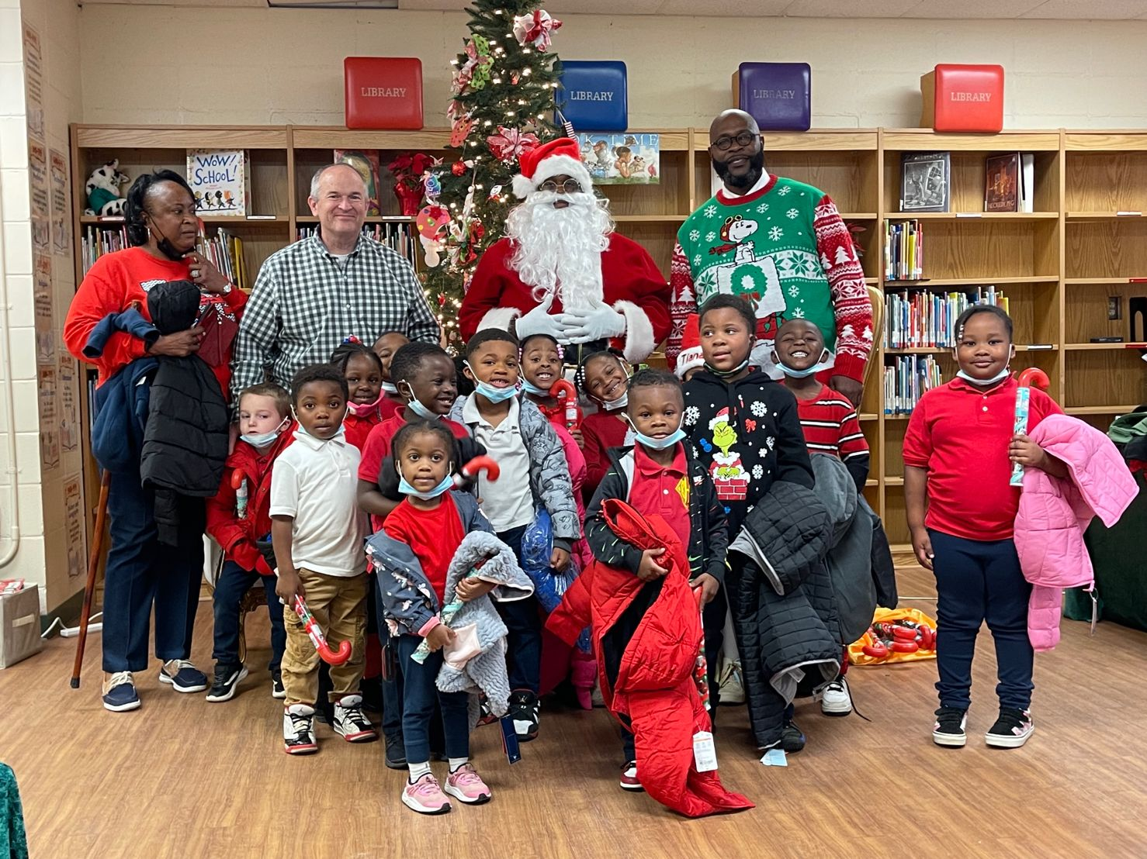

Presbyterian Home for Children’s new 20K sq. foot thrift store opens in Talladega
https://phfc.org/phfc-thrift-store-opens-in-new-larger-location/

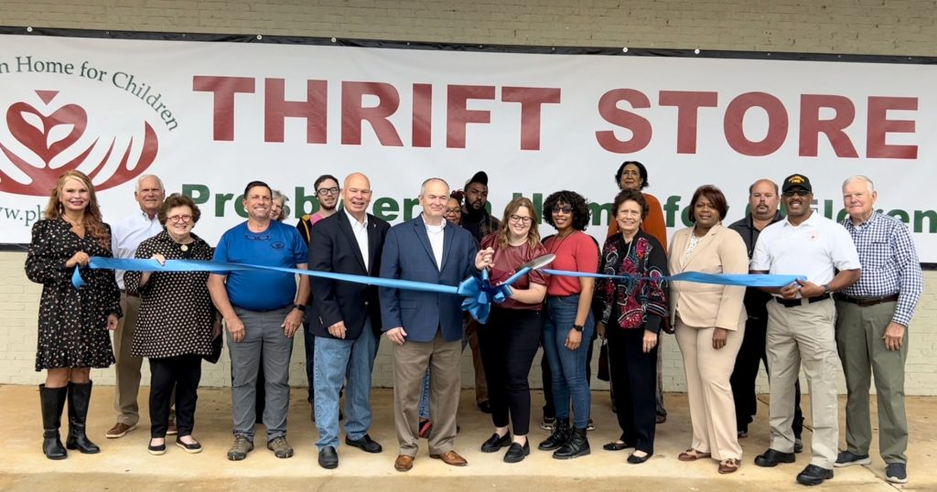

Construction has begun on six new tiny cottages at Union Village on the Presbyterian Home for Children’s campus. The new phase expands housing options for those who are blind, deaf, deafblind or multidisabled with the net rents helping offset the operating costs of caring for at-risk and homeless children and youth.
https://phfc.org/construction-begins-on-new-phase-of-affordable-specialized-housing-at-union-village/?mibextid=Zxz2cZ

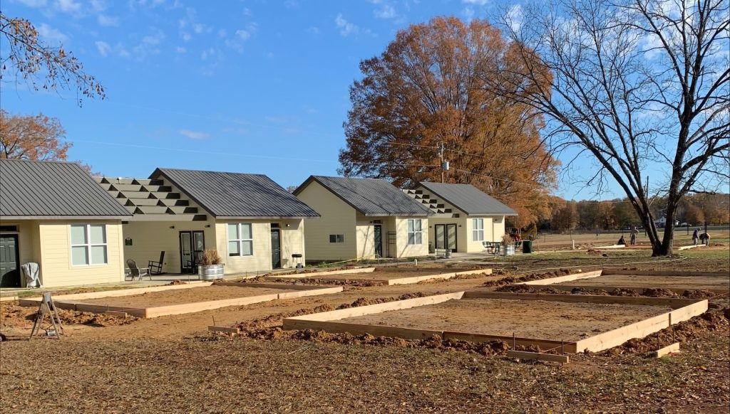

PHFC’s Fall 2022 Beginnings Newsletter
https://issuu.com/phfc/docs/final_koda_phfc.newsletter.fall.2022

Presbyterian Home for Children has launched a newly designed website that makes navigation easy and provides clear explanations of our services, who we are, and how to donate or volunteer.
Take a tour of the new phfc.org that will give you the feel of being “Home” thanks to beautiful photos and compelling narratives of what we do to help at-risk children and families from across Alabama. You can also donate there on our new, easy-to-fill-out form at https://phfc.org/donate/
The site also provides easy access to forms needed to apply for our services and to print materials for churches to share the word about the Home with their congregations.
Check it out at https://phfc.org!
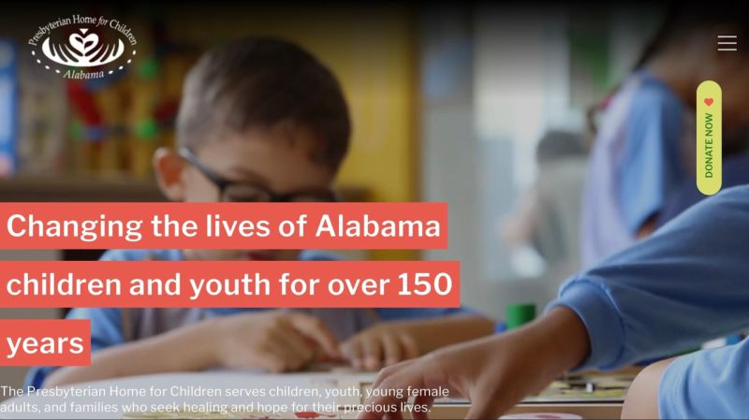

The Presbyterian Home for Children has achieved the Gold Seal of Transparency from Candid, a national nonprofit that tracks spending by other nonprofits. The Gold Seal demonstrates the Home has strong transparency for potential funders and donors. The determination used to be called GuideStar Seals of Transparency and is now called the Candid Seals of Transparency after the joining of the Foundation Center and GuideStar in 2019 to form Candid. Candid's data tools on nonprofits, foundations, and grants are the most comprehensive in the world as it collects data from nonprofits to show where the funding comes from, where it goes and how it is spent.
The Home was also honored to be recognized in September as a Top-Rated Nonprofit for the third year in a row by GreatNonprofits. GreatNonprofits is the leading provider of user reviews of charities and nonprofits. The Home was one of only seven other nonprofits in Alabama to earn the 2022 “top-rated” designation, receiving five-star reviews for every testimonial submitted this year.
