Ralls Coston in his sixth year
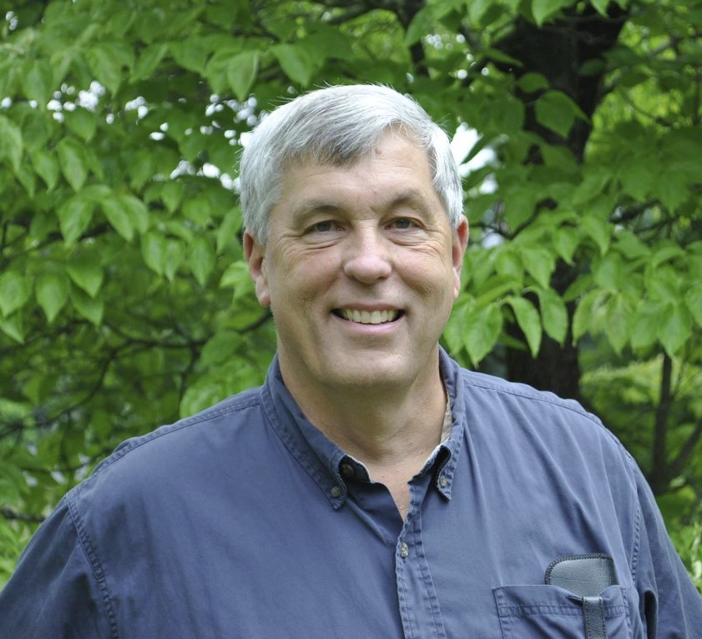
as Volunteer Missions Coordinator

Oakmont Chapel elder Ralls Coston has been Presbytery’s Volunteer Missions Coordinator for the past six years but, says Ralls, “the creativity for missions is in the churches.” Ralls reports the Birmingham area churches have sponsored at least 29 Habitat houses over the years. Among them are four houses coordinated by Presbytery, with another just underway.
When Ralls first became Missions Coordinator in 2016 he inventoried mission efforts underway in our churches and posted more than 30 stories that can still be found on the PS&L website. Among the most recent efforts is Project Empathy, initiated by Southminster PC. It has almost doubled its original goal of $50,000. That means that almost $10 million in medical debt, owed by the residents of 23 Alabama counties, including all the counties in the Black Belt, has been eliminated through RIP Medical Debt relief (https://ripmedicaldebt.org/)
Says general presbytery Sue Westfall, “Ralls is invaluable in promoting, organizing, and interpreting the common mission efforts of the presbytery. He explores needs and devises ways congregations can participate to alleviate those needs.”

Ralls feels that his 35 year career in public health provided with “on-the-job” training to serve as PS&L’s missions coordinator. In addition, a missions conference Ralls attended in 2014 provided him the motivation:
A minister spoke about working with small churches in South Carolina. He said that instead of the churches sitting around, yearning for the good old days of large congregations, he encouraged them to get up and accomplish what mission work they could. It was remarkable how much those churches were able to do. This inspired me and when the Mission Coordinator position came open, I went for it.

Ralls was in the first communicants’ class at Oakmont PC in 1965, and thus a charter member of that congregation where he has held a number of leadership positions. Currently, he is chair of the Session’s Adult Education committee; liaison for the Children’s Education committee; volunteer with the Fellowship committee; and, he teaches an adult Sunday School class.
Ralls and his wife, Denise, have been married for 35 years. He majored in English at the University of Montevallo, with a minor in history, training he currently puts to good use in writing a history of the Jefferson County Health Department. Thus far, Ralls has covered the decades been 1880 and 1952.

