Welcome, Mission Co-Worker, Mark Adams!

Today we welcome Mission Co-Worker, Rev. Mark Adams, as our guest. Mark has worked on the US/Mexico border in Douglas, AZ and Agua Prieta, Sonora, Mexico since 1998. Frontera de Cristo means “Border of Christ” in Spanish. It is a privilege to have him with us! He will be preaching at Edgewood Presbyterian Church, 850 Oxmoor Rd, in Homewood at 10:00am on Sunday, February 19. If you want to have lunch with Mark, me (Sue Westfall) and other interested people on Friday, February 17 around noonish, here in Birmingham, please let me know at swestfall@pslpcusa.org.

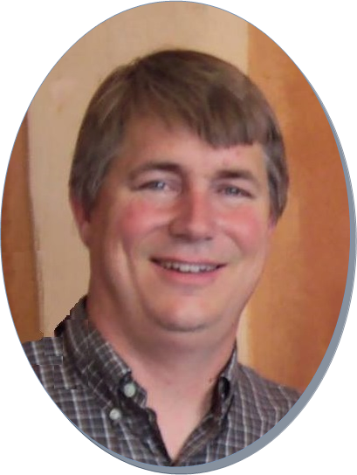

US COORDINATOR

Mark Adams
Mark Adams is a native of Clover, South Carolina, and a graduate of Columbia Theological Seminary in Decatur, Georgia. He was ordained in 1998 and has served as US Coordinator of Frontera de Cristo since that time. He is married to Miriam Maldonado Escobar, also a Presbyterian Church (USA) mission co-worker since 2011, and they have three children. Mark sees his 1994 border mission experience in Piedras Negras, Mexico, as the foundation for his present ministry.
Their website is http://fronteradecristo.org/ or to contact Mark it’s mark@fronteradecristo.org.

