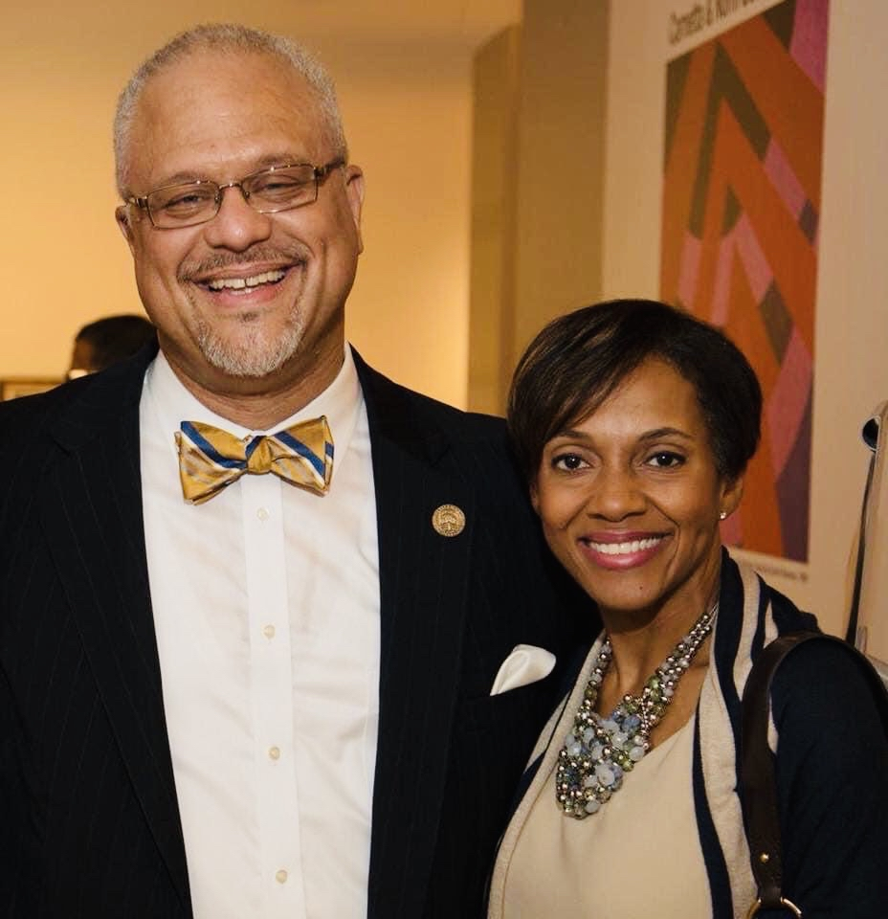
Joe Scrivner, Brown Memorial

Pastor with Many Roles,
Seems to Enjoy them All

Joe Scrivner is a pastor, professor, chaplain, and a grant writer. He is also active in General Assembly work, service to the Presbytery, and the Presbyterian Home of Children. He is also committed to his family as a husband, father, and grandfather, and enjoys the fun of chess, movies, and music. Surely, Joe has found a clock with more than 24 hours and a week with more than seven days. What’s more, he seems to enjoy it all!

Joe serves in Tuscaloosa as pastor of Brown Memorial Presbyterian Church (U.S.A.) and as Dean of Chapel at adjacent Stillman College. He graduated from Crichton College in his native Memphis, TN, earned a master’s at Reformed Theological Seminary in Jackson, MS, then went on to Princeton Theological Seminary, where he earned a Ph.D. in Old Testament studies. After four years at Princeton, he was hired in 2002 by Samford University to join their undergraduate religion faculty. Joe’s National Baptist affiliation matched up well with Samford’s Southern Baptist heritage. His local link to the PCUSA evolved from relationships with several local churches: Edgewood, IPC, and Westminster. His preaching at Westminster led to his invitation to preach on Easter Sunday, 2012, at Brown Memorial, where the college president, Dr. Ernest McNealey, was also chair of the pastor nominating committee. And, as the saying goes, "The rest is history."

Joe is the only installed pastor among the historically African American congregations in the Presbytery, but he is looking for ways to strengthen those congregations. In 2020, he helped Stillman win a $1 million “Thriving Congregations” grant from the Lilly Foundation. Joe is part of a team at Stillman helping 14 historically black congregations assess the meaning of “vitality” and what it would look like in each place. Four of the 14 are in this Presbytery: Brown Memorial, Westminster in Birmingham, First United, and Westminster in Tuskegee.

Scrivner commutes to Tuscaloosa from Birmingham, where he makes a home with Krysten Carter Holloway, a “cradle” Presbyterian. The two were married in 2018. Joe is the father of three adult children: Jocquelyn, and twins Jessica and Joseph II. He is a proud grandfather of four incomparable grandchildren: Adrian, 18, Aiden, 9, Lailah, 5, and Jonah, 2. He is also a delighted bonus dad for Krysten’s two children, Kennedy, 18, and Carter, 9.

