  - The Perpetual Care of Cemeteries in our Churches

Southminster Presbyterian Church~July 26, 2022~2:00 PM

Many of our congregations are the caretakers of cemeteries. These properties, hallowed ground that shelter the dead until the Resurrection, may be as small as a few graves or as large as 40,000 individual burial sites. The responsibilities facing church Sessions and cemetery trustees are significant, as we have an obligation to provide for these properties’ perpetual care.

The Presbyterian Foundation is receiving increasing numbers of inquiries from congregations and presbyteries about the financial implications of cemetery maintenance and upkeep and church leaders seeking strategies to fund the proper care of (especially older) graveyards and columbaria. The Foundation intends to expand its offering of resources on this subject beginning in 2023.

In order to better assess the needs of congregations and presbyteries, focus groups are being scheduled in presbyteries in selected areas. Our presbytery has been asked to participate, and we have agreed to do so.

Paul Grier and Robert Hay, Foundation staff, will meet with church leaders in person next month to hear experiences and concerns of congregations who maintain their own cemeteries. This discussion will not exceed 90 minutes, and the Foundation will provide to attendees basic but helpful materials that will assist in your management of cemetery properties.
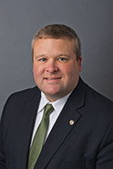
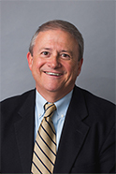
  - As light refreshments will be served, kindly notify us by July 18th of your plans to attend by contacting Tammy Strickland at 205.978.0320 or tstrickland@pslpcusa.org

