# 

# **Church Officer Training Event – Agenda**

**Five Smooth Stones**

David strapped Saul’s sword over the armor, and he tried in vain to walk, for he was not used to them. Then David said to Saul, “I cannot walk with these; for I am not used to them.” So David removed them. Then he took his staff in his hand, and chose five smooth stones from the wadi, and put them in his shepherd’s bag, in the pouch; his sling was in his hand, and he drew near to the Philistine. 1 Samuel 17:39-40

# 9:45 AM **Gathering** (coffee, juice, donuts/pastries, fruit)

# 10:00 AM **The First Stone**

Servant Texts, Duties & Vows Rev. Steve Jones

11:00 AM **The Second Stone**  TBA

The Book of Order

12:00 PM **The Third Stone** Rev. Jay Wilkins

Lunch and a word from Jay

1:00 PM **The Fourth Stone**

The Book of Confessions Chuck Kukal

2:00 PM **The Fifth Stone**

Sessions meet

***Bring your Bible, Book of Order and Book of Confessions***

**RSVP: Neil McCarter at fjhhwy2404@att.net or 205.499.8552**

**Oakmont**

**Chapel**

**Green Pond**

**Gardendale**

**Small Church Officer Training**

**Better Done Together~Hard to do this alone**

**January 12, 2019 @ Living River**

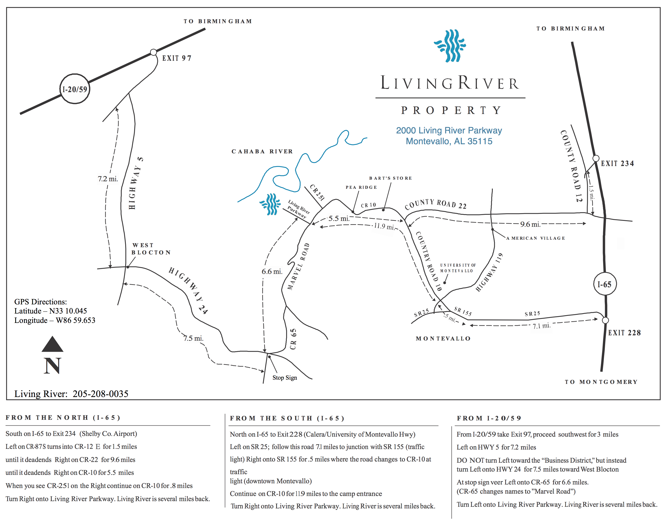

**Arrangements have been made with Living River for those participants who wish to come Friday, January 11 and stay overnight. The cost is $35.00 per person, per night. Meals** (dinner on Jan. 11 and breakfast on January 12) **are $8.00 each made payable to Living River.**

Yes! Sign me up!

Name___________________________________________________________________

Church__________________________________________________________________

Overnight stay (y/n)__________ Dinner (y/n)___________ Breakfast (y/n)___________

Phone ___________________________ Email__________________________________

Registration Deadline – January 9, 2019

Send Registrations to Neil McCarter ([fjhhwy2404@att.net](mailto:fjhhwy2404@att.net)) or 205.499.8552

***Bring your Bible, Book of Order and Book of Confessions***