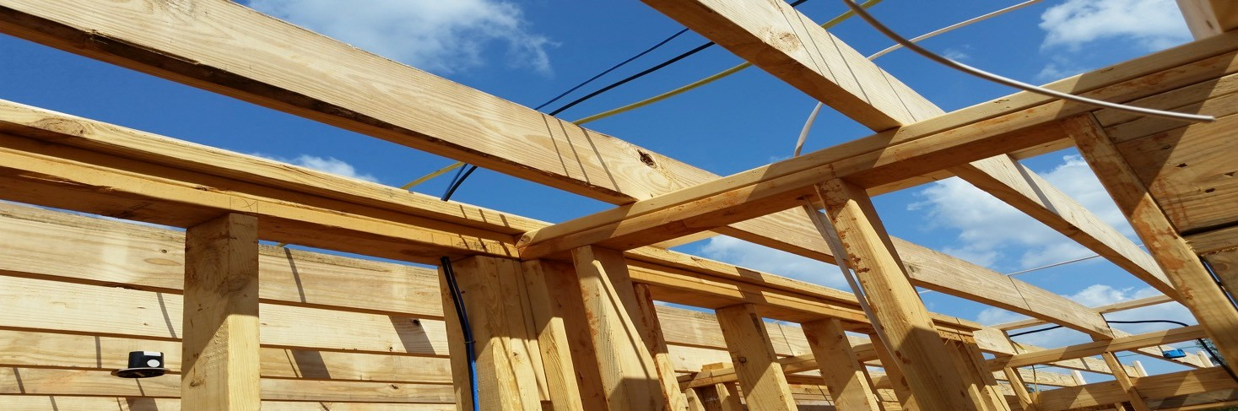


Presbytery of Sheppards and Lapsley www.pslpcusa.org
2022 Habitat House


Construction begins September 8, 2022



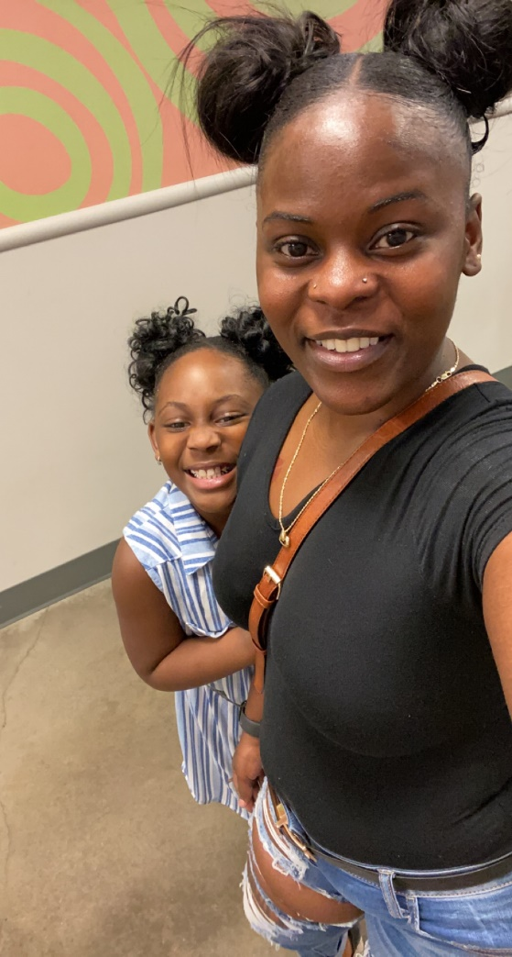


Sponsored by

Birmingham Area Churches in the Presbytery


We need volunteers! No construction experience is necessary, but you do have to be at least 14 years of age. Presbytery is also accepting monetary donations to help sponsor the house.

To give either of your time or money, contact:

- Your Minister
- Your Mission Committee chair
- Ralls Coston at the Presbytery office (205-263-6840 or rcoston@pslpcusa.org)
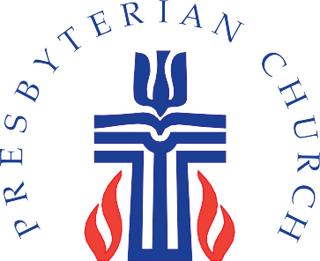

This year, 2022, Presbytery is sponsoring a Habitat house for Tonnesha Banks and her daughter, Catilynn. The house will be built at:873-77th St. S., in East Lake. Construction begins on September 8, 2022.

Tonnesha Banks was born and raised in Birmingham. She graduated from Woodlawn High School and now works for Amazon. She is the proud mother of one daughter, Catilynn, who is on the A/B Honor Roll at her school.They are both excited for this upcoming change!

Tonnesha is “truly grateful that God Himself gave you the kind heart to be able to help others.”

Build Location:

873-77th Street, South, Birmingham

