2022 PW Synod Triennial Gathering “Fueled to Serve” Workshop Selections

*Indicates a required field
*Email
*Name
*Preferred phone number
*Address, City, State, Zip
*Home Congregation
June 24, 2022
I will attend the Gathering Opening and Carol Bechtel Presentation (Part 1) Friday, June 24th at 8:30 AM CDT (9:30 AM EDT)
 | YES |  |  |  |  |  | NO
Consider Sabbath as a celebration, not a day of dreary formality. Sabbath reminds us to honor God who honors us by giving us a day each week to reset our pace, our priorities, and our lives. Come discover God’s intention for Sabbath.
WORKSHOPS June 24, 2022
1:00 PM CST (2:00 PM EDT) Choose Only ONE
 | Beth Templeton |  |  |  | Psychology of Poverty
Rather than looking at poverty statistics, this interactive class looks at underlying issues, factors, and causes of poverty to understand why people who are poor may think and act as they do. The goal is to decrease judgment and increase compassion by enlarging our understanding by addressing such things as definitions of poverty, funds of knowledge, and three levels of poverty. Dialogue and questions are highly encouraged.
 | Carol Friesen |  |  |  | Make Every Bite Count
While prayer fuels the soul, food fuels the body! This class will highlight simple steps you can
take to fuel your body by making every bite count!
3:00 PM CST (4:00 PM EDT) Choose Only ONE
 | Joe Genau |  |  |  |  | Inward to Outward: One Church’s Journey to Vitality
We look at the case study of one congregation that was on the brink of closure and found its way to vitality through embracing change, seeking transformation, committing to mission, and finding its calling as a More Light Presbyterian church. From the past 30 years of Edgewood Presbyterian Church, we will see what lessons we can draw out.
 | Joseph Scrivner |  |  |  |  | The Matthew 25 Two Step: Race & Poverty
In Matthew 25, Jesus urges us to focus our ministry on “the least of these”, focusing on three areas: building congregational vitality; eradicating systemic poverty; dismantling structural racism. Come and explore the implications of this bold vision and invitation to pursue justice.
REGISTRATION CONTINUES ON BACK
June 25, 2022
I will attend the Gathering Opening and Carol Bechtel Presentation (Part 2) Saturday, June 25th at 9:00 AM CDT (10:00 AM EDT)
Business Meeting (installation of leadership team) to follow immediately after presentation.
 | YES |  |  |  | NO
Consider Sabbath as a celebration, not a day of dreary formality. Sabbath reminds us to honor God, who honors us, by giving us a day each week to reset our pace, our priorities, and our lives. Come discover God’s intention for Sabbath.
1:00 PM CDT (2:00 PM EDT) Choose Only ONE
 |  | Kathy Reeves |  |  |  |  |  | The Who and How of Presbyterian Women
Learn how the variety of functions of the Directors serving on the Board contribute to building a stronger Presbyterian Women organization. The Board is led by a Moderator and Vice-Moderator. The Board of Directors of Presbyterian Women includes representation from each of the 16 Synods, Young Women, Members at Large, a Finance chair, a representative from the Presbyterian Mission Agency Board, and a Search Committee.
 |  | Allison Wehrung |  |  |  |  |  | Spiritual Reflection Through Visual Art
Together we'll talk about the ways visual art can enhance our spiritual lives (whether you make it or simply appreciate it!) and try our own hand at the practice of visio divina, or divine seeing, by considering several different artistic representations of one Scripture text.

Form and payment ($50.00) must be received by June 1, 2022.
Mail form and payment to: Judy Persons
500 E Rose St
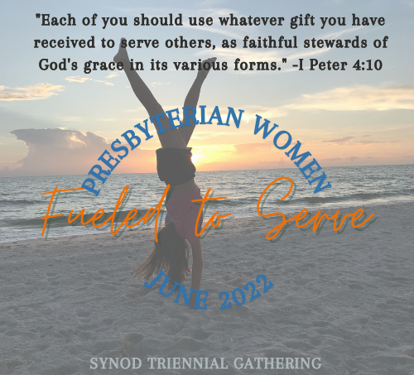

Jackson, AL 36545
Make a copy to keep for yourself

