Hidden Gems: Great Day Trips for You and the Grandkids

Looking to make lasting memories with the grandkids? Whether it’s art, animals, a farm tour, safari or a hot coffee watching the kids make crafts, some of the best day trips and events are just a car ride away! Here are four worth-every-minute ideas for spending the day with your grandkids. Click on the title of each event to go to the website for specifics.

Chalkfest Maple Grove
June 10th and 11th
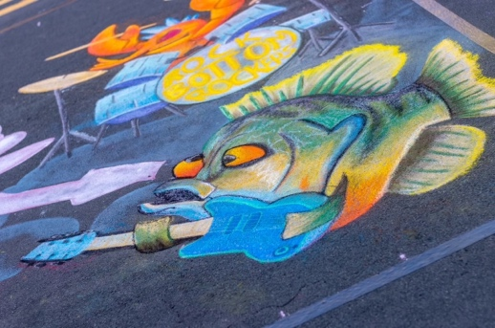
May 15th – July 17th (Mural Tour)

The largest street art festival in the Midwest, Chalkfest Maple Grove is a two-day street art festival with entertainment, food, and family fun! Chalkfest features sidewalk chalk art by professionals, amateurs and art enthusiasts from across the world! You’ll see breathtaking art including 3D images that will have you asking: how did they do that? Plus, don’t miss the Mural Tour which includes 16 sites in and around Maple Grove with 8’ x 8’ murals painted by Chalkfest artists.

Eagle Eye Farm
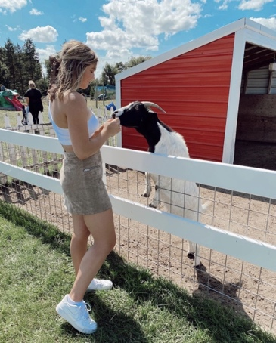
River Falls, WI

Roam a stunning farm property filled with Huacaya Alpacas, Valais Blacknose Sheep, llamas, Kune Kune pigs, mini Highland cattle and an eclectic group of chickens. You’ll tour the property, feed and pet the animals and learn the inner-workings of this farm which has caught the attention of National Geographic and was recently featured on the first season/episode 2 of “Going Fur Gold” airing on National Geographic Wild and streaming on YouTube and Hulu.

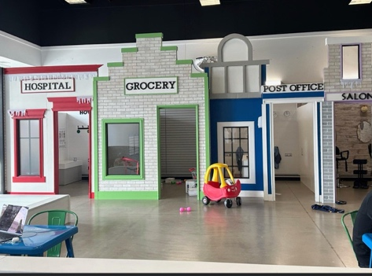
Minisota Play Café
The Shoppes at Arbor Lakes in Maple Grove

Sip on a latte while the grandkids enjoy the only indoor play space in Minnesota that combines an imaginative play area and a café. In an era of drive-thrus and “screen time”, MiniSota Play Cafe provides children and their caretakers a fun, clean place they both can enjoy.

Safari North
Brainerd, MN

Award-winning Safari North Wildlife Park features more than 150 species from six continents. You and the grandkids can feed giraffes or get an up-close look at species specific to Africa while riding a locomotive train through the exhibit titled: Expedition Safari. Animals featured include lions, hyenas, monkeys, zebras, wildebeest, ostrich and more! Safari North is also one of few zoos in the Midwest with cheetahs.

