I Connect Sunday School Lesson for 7/12/2020

SACRAMENT

Exodus 13:3, 12, 25
3Moses said unto the people, Remember this day, in which ye came out from Egypt, out of the house of bondage; for by strength of hand the Lord brought you out from this place:
21 . . . Moses called for all the elders of Israel, and said unto them, Draw out and take you a lamb according to your families, and kill the passover.
25 And it shall come to pass, when ye be come to the land which the Lord will give you, according as he hath promised, that ye shall keep this service.
Question: What was the Hebrew’s situation in Egypt?

Commentary

Exodus 12:21, 25
Moses’ instructions come at the time of Israel’s imminent departure from Egypt. Pharaoh’s stubborn resistance to freeing the enslaved Hebrew people has brought nine plagues on the Egyptians (see chaps. 7–10). The tenth, in which the firstborn of every family and even of cattle has died, finally persuades Pharaoh to release the Israelites (see 12:30, 31). (see chart)
The term passover (from the Hebrew noun pesah) describes God’s exemption of the Israelites from the tenth plague. Following divine direction to place lamb’s blood on their doorposts, they save their firstborn children from death (see vv. 21–23). After this event, its annual observance—called Passover in memory of God’s “passing over” their homes—becomes central to Jewish tradition (see vv. 24–27). Isaiah 31:5 uses the related word pāsah to depict God as a protection and defense, saying of Jerusalem, “He will deliver it; and passing over [pāsah] he will preserve it.”
“Kill the passover” refers to killing the sacrificial animal for the commemorative meal. One source notes that sacrificing a newborn lamb was already practiced annually to ensure protection of the entire flock. So Moses’ mandate would likely have been familiar to his people.
Centuries later, Christ Jesus celebrates Passover with his disciples during the last supper, and makes reference to his coming sacrifice (see Luke 22:14–20). John the Baptist had identified Jesus as the “Lamb of God” (John 1:29) at the outset of the Master’s career. And First Peter writes of humanity’s redemption by “the precious blood of Christ, as of a lamb without blemish and without spot” (1:19).

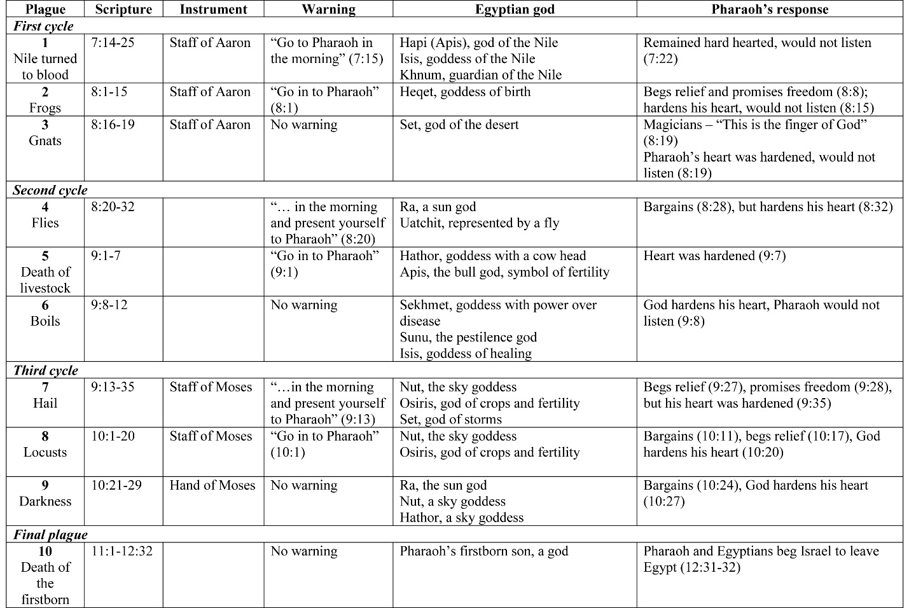

Exodus 14:5, 7, 10, 13 (to :), 15, 16 (to :), 21, 22, 30 (to ;)
5And it was told the king of Egypt that the people fled: and the heart of Pharaoh and of his servants was turned against the people, and they said, Why have we done this, that we have let Israel go from serving us?
7And he took six hundred chosen chariots, and all the chariots of Egypt, and captains over every one of them.
Commentary
Jewish historian Josephus reported that Pharaoh’s pursuit of the Israelites also included 50,000 horsemen and 80,000 foot soldiers. The degree of force brought against the Israelites illustrates Pharaoh’s headstrong determination to overcome the Israelites. His subsequent defeat conclusively demonstrates God’s power (see vv. 27, 28).
10And when Pharaoh drew nigh, the children of Israel lifted up their eyes, and, behold, the Egyptians marched after them; and they were sore afraid: and the children of Israel cried out unto the Lord.
13And Moses said unto the people, Fear ye not, stand still, and see the salvation of the Lord, which he will shew to you to-day:

Other Translation

Exodus 14:13 from the Common English Bible
But Moses said to the people, “Don’t be afraid. Stand your ground, and watch the Lord rescue you today.” ...

15And the Lord said unto Moses, Wherefore criest thou unto me? speak unto the children of Israel, that they go forward:
16But lift thou up thy rod, and stretch out thine hand over the sea, and divide it:
21And Moses stretched out his hand over the sea; and the Lord caused the sea to go back by a strong east wind all that night, and made the sea dry land, and the waters were divided.

22And the children of Israel went into the midst of the sea upon the dry ground: and the waters were a wall unto them on their right hand, and on their left.
30Thus the Lord saved Israel that day out of the hand of the Egyptians;
Comment: Moses advanced a nation to the worship of God spiritly instead of humanly. But how did some of the Hebrews respond to life in the wilderness?

Commentary

Exodus 14:10, 13
Though crying out to God, the Hebrew people reveal their faithlessness with their complaints: “It had been better for us to serve the Egyptians, than that we should die in the wilderness” (v. 12). By contrast, writes a commentator, “Moses reframes the crisis of Israel around the presence, power, and fidelity of Yahweh.”

Micah 6:6, 8
6Wherewith shall I come before the Lord, and bow myself before the high God? shall I come before him with burnt offerings, with calves of a year old?
8He hath shewed thee, O man, what is good; and what doth the Lord require of thee, but to do justly, and to love mercy, and to walk humbly with thy God?

Other Translation

Micah 6:8 from the Contemporary English Version
The Lord God has told us
what is right
and what he demands:
“See that justice is done,
let mercy be your first concern,
and humbly obey your God.”

Comment:

Seems simple. And it does not require sacrificing animals.

Is it this simple?

What is your experience?

Commentary

Matthew 5:8
Mosaic law had many rules for ritual purity providing for outward cleansing (see example in Numbers 8:6, 7). But it was recognized that thought needed purification, too. Psalms 51:10, for instance, voices the plea “Create in me a clean heart, O God; and renew a right spirit within me.”

3 Micah 6:6, 8
For many, sacrificing to God had become a ritual of appeasing Him, a rite possible only for those who could afford the costly gifts detailed in verses 6 and 7. Micah exposes the fallacy of this practice, then declares God’s requirement—their just, merciful, and humble lives. A scholar portrays this sacrifice as “the offering of one’s whole self on the altar of complete commitment to God.”
Another source explains, “Obedience to the commands and requirements of God is considered a response to the grace of God, not a requisite for it.… They have been granted a special relationship, a unique calling; what more could be given? How could Israel do anything but bow in gratitude …?”

John 4:23 the, 24
23the hour cometh, and now is, when the true worshippers shall worship the Father in spirit and in truth: for the Father seeketh such to worship him.
24God is a Spirit: and they that worship him must worship him in spirit and in truth.
Comment: Sounds simple?

Matthew 16:24
24Then said Jesus unto his disciples, If any man will come after me, let him deny himself, and take up his cross, and follow me.
Comment:
What is the cross that we are to take up?
What cross have each of us taken up?

I Corinthians 10:1–4 brethren
1brethren, I would not that ye should be ignorant, how that all our fathers were under the cloud, and all passed through the sea;
2And were all baptized unto Moses in the cloud and in the sea;
3And did all eat the same spiritual meat;

4And did all drink the same spiritual drink: for they drank of that spiritual Rock that followed them: and that Rock was Christ.
Comment:
What does the reference to “Rock” mean?

I Corinthians 11:23–25, 28 let
23For I have received of the Lord that which also I delivered unto you, That the Lord Jesus the same night in which he was betrayed took bread:
24And when he had given thanks, he brake it, and said, Take, eat: this is my body, which is broken for you: this do in remembrance of me.

25After the same manner also he took the cup, when he had supped, saying, This cup is the new testament in my blood: this do ye, as oft as ye drink it, in remembrance of me.
28let a man examine himself, and so let him eat of that bread, and drink of that cup.
Commentary
Christ Jesus’ words (see Luke 22:20) are quoted by Paul in this verse. “The new testament” signifies a new covenant between God and man as described in Jeremiah 31:31–34, distinct from the law of Moses. Where the Mosaic covenant was based on obedience to the letter of the law, the Christly covenant emphasizes a loving relationship with God.
Sometime in the second century ad the title “New Testament” was given to the collected writings of the Christian faith. Diathēkē is the Greek word translated both testament and covenant, but scholars consider covenant to more closely represent this biblical collection. The term testament comes from testamentum, the Latin word for binding agreement. “Old Testament” is the Christian name for the earlier scriptural canon. The Jewish faith refers to it as the Tanakh, the Hebrew Bible, or the Hebrew Scriptures.

John 21:1–6, 9, 12
1After these things Jesus shewed himself again to the disciples at the sea of Tiberias; and on this wise shewed he himself.
2There were together Simon Peter, and Thomas called Didymus, and Nathanael of Cana in Galilee, and the sons of Zebedee, and two other of his disciples.
3Simon Peter saith unto them, I go a-fishing. They say unto him, We also go with thee. They went forth, and entered into a ship immediately; and that night they caught nothing.

4But when the morning was now come, Jesus stood on the shore: but the disciples knew not that it was Jesus.
5Then Jesus saith unto them, Children, have ye any meat? They answered him, No.

6And he said unto them, Cast the net on the right side of the ship, and ye shall find. They cast therefore, and now they were not able to draw it for the multitude of fishes.
9As soon then as they were come to land, they saw a fire of coals there, and fish laid thereon, and bread.
12Jesus saith unto them, Come and dine. And none of the disciples durst ask him, Who art thou? knowing that it was the Lord.
Comment:
The last meal Jesus had with his Disciples we call The Last Supper.
How do the circumstances of this meal differ?
What do you imagine was going on in the minds of the Disciples?
How did the Disciples respond?

