Tuesday Morning Bible Study
April 14, 2020 – 10:00 to 11:00 AM
A study of the division and dissention throughout Methodist history
Text reference: The Story of American Methodism, Frederick A. Norwood, Abingdon Press, Nashville, 1974
We’ll use this guide for the duration of the discussion leading up to this final study on Division and Dissention of the Methodist Church.
Ancestral Heritage: 1725—1784 (John Wesley 1703-1791)
Events during the life of John Wesley including his journey to America, return to England, separation from the Anglican Church, introduction to church hierarchy including establishment of the Conference concept
Pioneer Development: 1784—1860
Revivalism and Camp Meetings, the beginnings of Black Methodism, Reform movement and the Methodist Protestant Church, Slavery, and early theological expression
Settled Institution: 1860—1914
Civil War and reconstruction, Black Churches, Sectarian movements, Education and the printed word, New theology, and missionary enterprise.
Ecumenical Transformation: 1914—1970
New Liberalism and New Reformation, the Social Gospel, The Methodist Church 1939—1968, The Evangelical United Brethren, United Methodism in American Culture, and Denominationalism and Christian Unity
Current General Conference Consideration
“Continuity in face of social change...”
“Shifts in UMC Institutional view on Sexuality”
1972 General Conference first introduced language into the Book of Discipline of the United Methodist Church
2020 General Conference issues
Hang on to the following “History of the UMC” for reference to the dates I have identified above.

History of the UMC
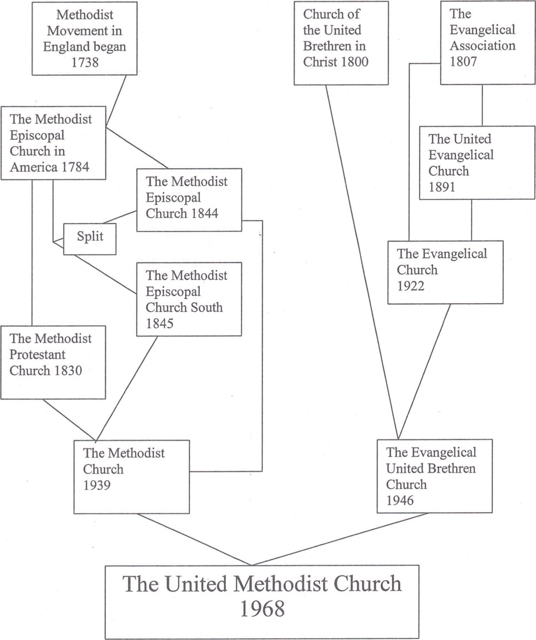
I would like to wrap up the Wesleyan Study and move on to other possibilities for study. We’ll talk about that at the end of the April 21 study, so give some thought to study options you would like us to consider.
For today, we’ll begin the final stages of the study Pastor Lara had started seemingly so long ago. Don’t know about you, but I’d like to get back to some actual face to face time as much as I’m really getting the hang of virtual classroom.
Ancestral Heritage: 1725—1784 (John Wesley 1703-1791)
Journey to America, return to England

Separation from the Anglican Church

Introduction to church hierarchy including establishment of the Conference concept

Pioneer Development: 1784—1860
Revivalism and Camp Meetings

Beginnings of Black Methodism

Reform movement and the Methodist Protestant Church

Slavery

Early theological expression

Settled Institution: 1860—1914
Civil War and reconstruction

Black Churches

Sectarian movements

Education and the printed word

New theology

Missionary enterprise

Ecumenical Transformation: 1914—1970
New Liberalism and New Reformation

The Social Gospel

The Methodist Church 1939—1968

The Evangelical United Brethren

United Methodism in American Culture

Denominationalism and Christian Unity

Current General Conference Consideration
“Continuity in face of social change...”

“Shifts in UMC Institutional view on Sexuality”

1972 General Conference first introduced language into the Book of Discipline of the United Methodist Church

2020 General Conference issues

