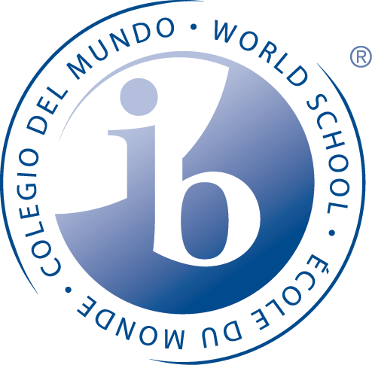
PAMOJA
Online IB Course Opportunity

Pamoja Education is the only IB approved online provider. Sequoia will only be offering IB Pamoja courses that we are unable to offer in our master schedule. All courses are taught over two years. These are enrichment courses and are not granted high school credits but should be added to college applications. Pamoja does not issue a transcript and thus, they cannot be used to fulfill UC/CSU a-g requirements. However, they should be added to all college applications as an additional educational experience. An elective course may be used to satisfy Group 6 of the IB Diploma.

Online IB Courses:
Business & Management HL *
Economics SL*
Economics HL*
Philosophy SL*
Film SL
Psychology HL*
ITGS HL*
Mandarin ab initio (a level below SL)
Spanish ab initio (a level below SL)
French ab initio (a level below SL)

*Indicates a UC a-g approved course (but due to transcript issue, cannot be used to fulfil the requirement since CSU/UC requires a transcript)

Why Take a Pamoja Course:
- Access a wider range of IB courses that Sequoia is unable to offer in our schedule

- You could not fit all the courses you wanted in your regular school day
- IB approved meeting all the rigorous requirements of IB
- A worldwide online community- unique experience to study with people around the world
- Open to both Diploma candidates & Course Students: Can use to fulfill a Diploma requirement
- Flexibility to fit in an IB course around other commitments
- You are a transfer student from another IB school and Sequoia IB course offerings did not match up with your original school’s IB courses
- Students can transfer into the Pamoja course for year two IF they have already been enrolled in that course for year one elsewhere. This benefits students transferring into Sequoia from another educational institution.

Academic Calendar:
- All courses are taught over a 2 year period. You MUST commit for two years
- Courses begin on September 6th through May 30th for 2017-2018
- Courses have weekly lessons: Students should commit the same amount of time to an online course that they would to a face-to-face IB course at Sequoia
- Students sit for the IB exam at Sequoia in May of the second year

Cost:
- Academic Year 2017/2018 fee = $1292. 2018/2019 fee = $1356. A fee is charged for each academic year
- Sequoia High School may qualify for an all school discount lowering the fee to $895 for 2017/2018
- Cost subject to change each year
- The cost must be carried by the student and family. Scholarship applications available from Pamoja for students demonstrating financial need
- This does not include the cost of the IB exam. (Free-reduced lunch students receive a scholarship for IB exam fees)

Scholarship:
- Pamoja offers scholarships to cover the two year course (2017/2018 through 2018/2019) for students demonstrating financial need as well as commitment to completing their online studies.
- Scholarships will pay for tuition for students qualifying for free/reduced lunch.
- See Pamoja Application for qualifications, application process and deadline

Sequoia Pamoja Application
Pamoja Course Qualifications:
- A student willing to commit a large amount of time outside of your regular school day to this IB
online course. (Requires the same amount of time as a face-to-face Sequoia IB course)
- A self-disciplined student who can manage their time independently
- A student able to secure access to the internet with Skype capability (off or on campus)
- A student who demonstrates academic commitment through their GPA.
- A student who is committed to the course for 2 years

Deadline:
- Applications are due no later than Friday, May 26th
- Return to Ms McCahon or Ms Patience in the IB Office

Requirements:
- Calendar management and check-ins with on-site Sequoia Pamoja Coordinator, Ms McCahon
- Commitment to the full two year course.
- Scholarship Recipients: If a scholarship student drops from the course before it finishes, Pamoja charges a fee. You must be fully committed.

Scholarship Qualification & Award:
- Award: Full Pamoja course tuition for both academic years.
- Students must qualify for free/reduced lunch
- Scholarship recipients cannot be transfer students per Pamoja policy (entering into year 2)

Directions:
Please answer all questions on the front and back side of this sheet or attach typed up answers on a separate sheet. Return to the IB Office no later than May 26th

Name:

1. Please check one:
IB Diploma Candidate IB Course Student

2. Do you qualify for free/reduced lunch? (Based on 2016-2017 school year)
Yes No
Grade: _______

3. | What course do you want to take? Please check ONE box.

Business & Management HL Economics SL
Economics HL
Philosophy SL ITGS HL
Film SL
Psychology HL
French ab initio
Mandarin ab initio Spanish ab initio

Sequoia Pamoja Application

4. Why do you want to take this IB course online? Include all your reasons.

5. How will you independently manage your time to complete the Pamoja online IB course?

6. Where will you access the internet (on or off campus)?

7. How can we be confident that you will stay committed for the next two academic school years?

- What do you hope to get out of this online learning experience?

- What days of the week and times will you spend on your Pamoja course?

- How comfortable are you with using technology including blogs, Skype etc.?

Scholarship Application Questions 11 – 15

We recommend you type these questions on Word or a Google document and save your answers. If approved by the IB office to submit your scholarship application to Pamoja, you will need to submit these same answers typed to Pamoja so easiest to type them now and save them.

- Why do you want to take an online course?

- What are your reasons for applying for a scholarship? E.g. financial need, etc..

- Please describe in detail how you will commit to participating in your online course.

- Should your application be accepted, we may wish to ask you online journey with Pamoja for marketing purposes.

- Any additional comments. (Anything else we should be aware of when considering your scholarship application. Any other helpful information).

Scholarship Application Next Steps:
- Turn into Ms McCahon for review
- If approved, Ms McCahon will meet with you to help you complete the Pamoja scholarship application online
- All scholarships decisions are made by the Pamoja organization

