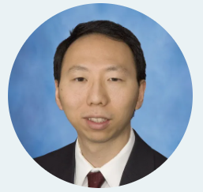

Jules Lin, M.D. is a faculty member in the Section of Thoracic Surgery at the University of Michigan and is the surgical director of the Lung Transplant Program. He is the inaugural Mark B. Orringer Professor. He is currently serving on the Robotic Surgery Steering Committee. He is also involved in establishing national guidelines as a member of the National Comprehensive Cancer Network (NCCN) Non-Small Cell Lung Cancer Panel and the American College of Surgeons Surgical Standards Manual, Lung Group.
Dr. Lin was a Phi Beta Kappa graduate of Indiana University and received his undergraduate degree with highest distinction in 1995. He received his medical degree from Harvard Medical School in 1999 and completed his General Surgical Residency in 2006 at the University of Michigan. During this time, he also completed a Surgical Critical Care Fellowship in 2003 and a research fellowship in the Thoracic Surgery Tumor Biology Laboratory in 2004 for which he received the Moses Gunn Young Investigator and James Crudup Awards. He completed his Cardiothoracic Surgery Residency at the University of Washington.
His research interests include investigating the molecular biology of esophageal and lung carcinoma and translating these findings into new techniques for screening, staging, and tailoring therapies for individual patients.

