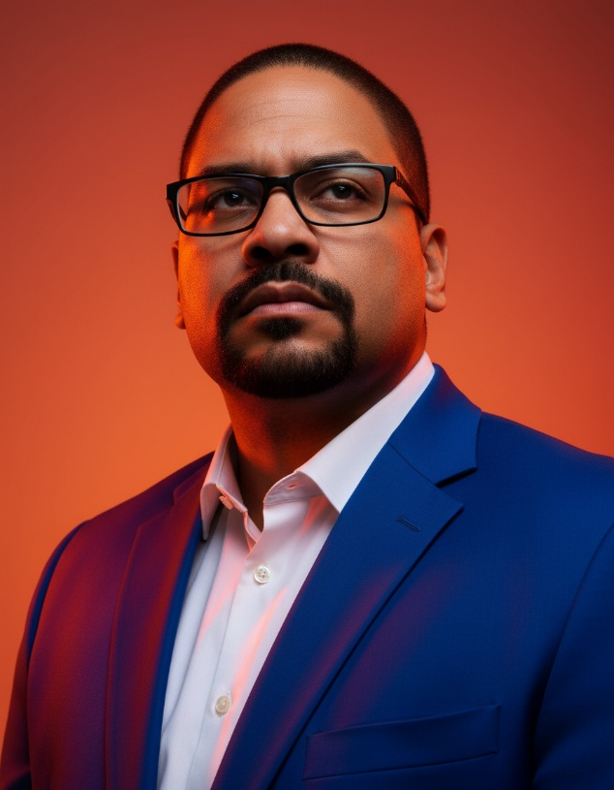
Dr. Val Alexandre Torres MD, MBA, FIADFE is a healthcare and AI executive, but at his core, he’s an ecosystem builder. His work is about bringing the right people, organizations, and opportunities together and turning those relationships into real impact.
He serves as Co-CEO and Head of AI & Emerging Technologies at FOCUS International Global, a medical and dental education company. At FOCUS, he leads BlueCloudX LATINO, connecting the Latin Diaspora, LATAM, the Caribbean, Spain, and Portugal with a global ecosystem of 2.6+ million healthcare professionals across 196+ countries and 700,000+ organizations.
Through BlueCloudX LATINO, he also helps expand access to healthcare and life sciences scholarships for professionals, including physicians, nurses, first responders, students, PhDs, CRCs, CRAs, project managers, and others.
His work brings together healthcare professionals, hospitals, research sites, governments, universities, pharma, biotech, medical device, technology companies, and other industry partners to build global communities and coalitions that actually work together.
Dr. Torres is also Co-Founder & CEO of Latino Executive Exchange, a human-centered AI-first Latino Leadership Society that serves as a trust engine, and ecosystem builder and amplifier for the Latinos and their allies.
For him, it really comes down to something simple: connect good people, break down silos, create opportunities, and build things that make a difference. So that we can improve health outcomes, and help people to live their best lives.

