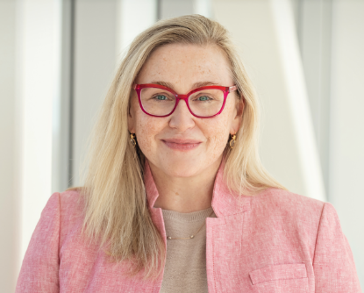

Kelly Michele Malloy, MD, MBA is a head and neck surgical oncologist at the University of Michigan where she is professor of otolaryngology and head and neck surgery and Chief Clinical Officer for Michigan Medicine. Dr. Malloy's clinical work focuses on the comprehensive surgical management of patients with head and neck malignancies, with additional expertise in head and neck melanoma and advanced cutaneous oncology. She is a physician executive with over a decade of experience in hospital and health system leadership. As chief clinical officer, she has extensive operations, finance, patient experience, quality, safety, policy, and governance responsibility for the adult hospitals of Michigan Medicine. Prior to this role, she served as associate chief clinical officer for surgical and rehabilitation services and as a patient care unit medical director at both Michigan Medicine and the Hospital of the University of Pennsylvania.

