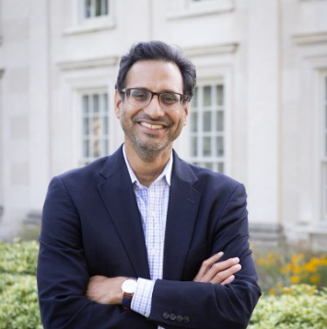
Kedar Mate, MD, is the Founder & CMO of Qualified Health AI, a digital health company that is building the infrastructure needed to successfully scale healthcare AI safely and securely. At Qualified Health, Dr. Mate sets the clinical vision and strategy to improve outcomes for patients and providers. Prior to this, Dr. Mate was the President and CEO of the Institute for Healthcare Improvement (IHI) and a member of the faculty at Weill Cornell Medical College. Dr. Mate’s scholarly work has focused on digital enablement, health care quality, health equity, and approaches to achieving large-scale change. Previously Dr. Mate worked at Partners In Health, the World Health Organization, and Brigham and Women’s Hospital. He is widely published, serves on multiple health system and company Boards, and has received numerous honors including a Soros, Fulbright and Aspen Fellowship, and was recently named to Modern Healthcare’s Top 100 Most Influential healthcare executives in the US. With Dr. Donald Berwick, he hosts the successful healthcare podcast “Turn On The Lights,” which aims to demystify some of healthcare’s most persistent issues. He graduated from Brown University with a degree in American History and from Harvard Medical School with a medical degree. You can follow him on LinkedIn @KedarMateMD

