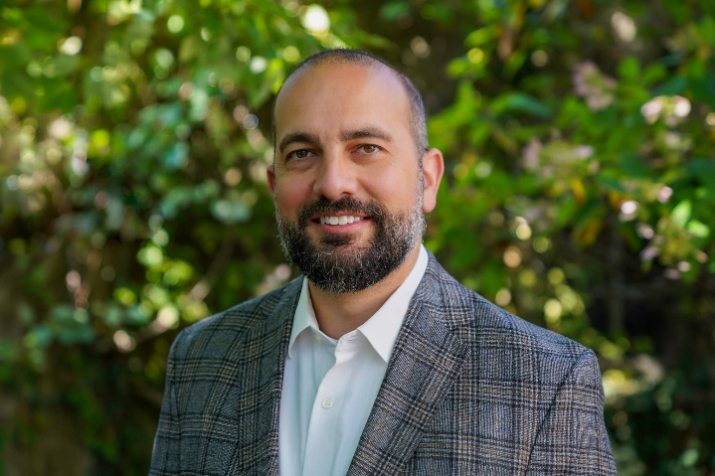
Salvatore Russo
Sr. Director of Substance Use Disorder and Prevention
Hegira Health Inc.
Sal Russo is Sr. Director of Substance Use Disorder and Prevention at Hegira Health Inc., where he oversees substance use disorder services across the full continuum of care, including residential treatment, withdrawal management, outpatient, intensive outpatient, peer services, and prevention. Sal has spent his career strengthening access to behavioral health treatment and building the operational systems that make quality care sustainable. He's active in Michigan's behavioral health policy landscape, contributing to MDHHS advisory councils and Opioid Task forces. Sal has also provided administrative leadership across outpatient and residential treatment services with Ascension Health.

