Dr. Andru Bageac—Remote Radiology Group
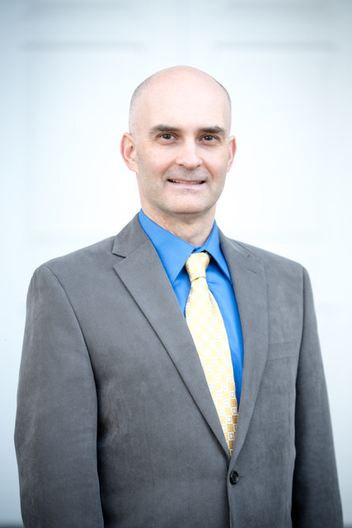
Alexandru Bageac, MD MBA
Nuclear Radiologist, Radiology Associates of North Texas, P.A.
AlexandruBageac@mhd.com
No disclosures
Dr. Bageac is a diagnostic radiologist in private practice, specializing in nuclear medicine and oncologic imaging. He is the medical director for the Department of Radiology at Methodist Dallas Medical Center and the chair of the Radiation Safety Committee of the Methodist Health System in Dallas, TX. After graduating from Harvard Medical School, Dr. Bageac completed his radiology residency and nuclear radiology fellowship at Beth Israel Deaconess Medical Center in Boston. While a private practice radiologist in Portland, OR, he earned an MBA in Entrepreneurship from the F.W. Olin School of Business at Babson College. Dr. Bageac has been involved for many years with the Society of Nuclear Medicine and Molecular Imaging (SNMMI), where he currently serves as the co-chair of the Committee on Community-Based Nuclear Medicine.

