Amir Rubin, MHSA, MBA
Chief Executive Officer and Founding Managing Partner, Healthier Capital
Former Chief Executive Officer, One Medical
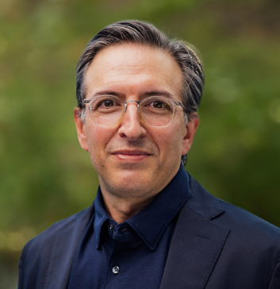
Amir Dan Rubin has focused his career on helping transform health care. He currently serves as CEO & Founding Managing Partner of Healthier Capital, a venture capital firm focused on technology-powered healthcare innovation. He previously served as Chair & CEO of the technology-enabled primary care company, One Medical, which he took public in 2020, and which was acquired by Amazon in 2023. At Amazon, he launched One Medical membership as an add-on to Prime. Prior to that, Amir served as an EVP at the Fortune 5 company, UnitedHealth Group and its Optum division. Prior to that, he served as CEO at Stanford University’s health system, COO at UCLA’s health system, COO at SUNY Stony Brook’s health system, and in leadership roles at Memorial Hermann’s health system. He has twice received an EY “Entrepreneur of the Year” award.

