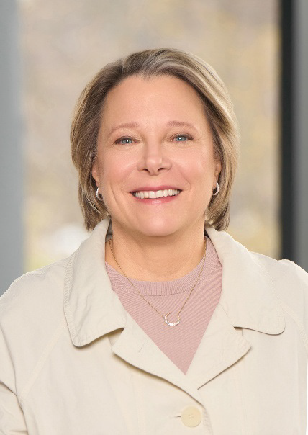

Robin Damschroder, MHSA, FACHE
EVP, Chief Financial Officer and
President, Value Based Enterprise
Henry Ford Health
Robin is EVP, Chief Financial Officer, and President, Value Based Enterprise, at Henry Ford Health, one of the nation’s leading comprehensive, integrated health systems. She provides strategic, financial, and operational leadership to the $13 billion health system that includes 12 hospitals, 550+ sites of care and 50,000 team members
As President of the Value-Based Enterprise, Robin focuses on advancing care and coverage to improve outcomes, access, equity, and affordability. Her responsibilities include Henry Ford Health’s wholly owned insurance company, Health Alliance Plan, which has more than 500,000 members; the Community Care Services division, which includes pharmacy, post-acute care and retail; and Populance, Henry Ford Health’s population health and care management subsidiary. Robin also collaborates directly with Henry Ford Health’s primary health, clinically integrated networks, and accountable care organizations.
As CFO, Robin is deeply engaged in business development, strategic venture funds, revenue cycle, information technology, and financial operations. Her unique dual role supports innovation across the continuum to drive improved outcomes, experience, and affordability.
Robin was an integral team member in the development of Henry Ford Health’s partnerships with Ascension Michigan, the Shirley Ryan AbilityLab, Michigan State University, and the Detroit Pistons.
She currently serves on the boards of Henry Ford Health+Michigan State University Health Sciences, Truveta, Medica, Detroit Riverfront Conservancy, and the Healthcare Financial Management Association (HFMA). She also volunteers her time to the American Heart Association’s Heart and Stroke Walk and Detroit’s Women of Tomorrow mentoring program.

