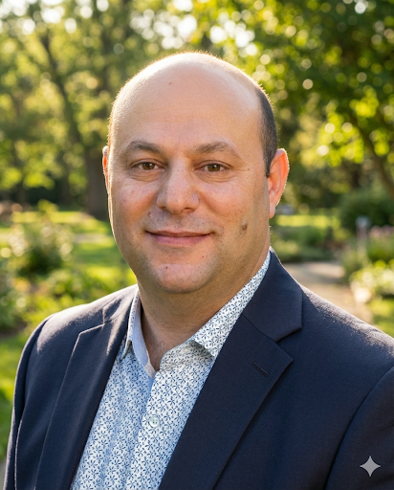
Dmitry Beyder is a Certified Nuclear Medicine Technologist and SNMMI-TS Fellow at Barnes-Jewish Hospital who integrates clinical excellence with strategic healthcare administration. Holding a Master of Public Administration from New York University, he has built a distinguished career at premier academic institutions, including Memorial Sloan-Kettering Cancer Center and Oregon Health & Science University. Currently at Barnes-Jewish Hospital/Washington University, Dmitry has scaled PET and Theranostics programs while pioneering innovations that expand patient access to care. As a past President of SNMMI-TS, he remains a dedicated advocate for the global technologist workforce and the expansion of molecular imaging collaborations.
567-413-0348
dmitry.beyder@bjc.org

