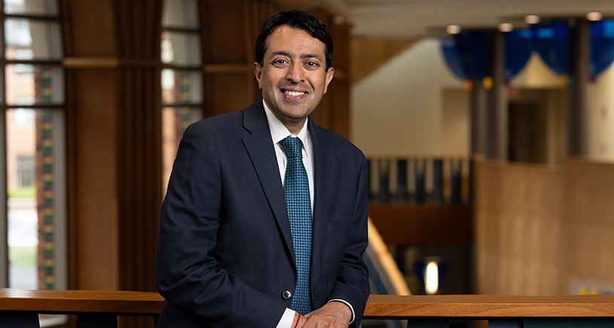

Professional Bio:
Dr. Anand K. Parekh is the Chief Health Policy Officer at the University of Michigan School of Public Health and Senior Advisor at the Institute for Healthcare Policy and Innovation. In this capacity, he helps translate the care, practice, and research occurring at the university to policymakers to drive health impact. Parekh also serves as an adjunct professor in health management & policy.
Previously, Parekh served as the Chief Medical Advisor at the Bipartisan Policy Center (BPC) where he provided clinical and public health expertise across the organization. From 2015 to 2025, he led specific efforts tackling policy issues such as the COVID-19 pandemic, future of public health, opioid crisis, and obesity epidemic & nutrition. His healthcare expertise was recognized by the Washingtonian in its listing of Washington DC’s 500 Most Influential People.
Prior to joining BPC, he completed a decade of service at the U.S. Department of Health and Human Services (HHS). As an HHS Deputy Assistant Secretary for Health in the Senior Executive Service from 2008 to 2015, he developed and implemented national initiatives focused on prevention, wellness, and care management. Specifically, he played instrumental roles in the implementation of the Recovery Act’s Prevention and Wellness Fund, the Affordable Care Act’s prevention initiatives, and HHS’ Multiple Chronic Conditions Initiative. He received the Surgeon General’s Outstanding Service Award for his efforts.
Briefly in 2007, he was delegated the authorities of the HHS Assistant Secretary for Health overseeing ten health program offices and the U.S. Public Health Service Commissioned Corps. Earlier in his HHS career, he played key roles in public health emergency preparedness efforts related to pandemic influenza and bioterrorism as special assistant to the science advisor to the secretary.
Parekh is a board-certified internal medicine physician, a fellow of the American College of Physicians, and an adjunct associate professor of medicine at Johns Hopkins School of Medicine, where he previously completed his residency training in the Osler Medical Program of the Department of Medicine. He provided volunteer clinical services for many years at the Holy Cross Hospital Health Center, a clinic for the uninsured in Silver Spring, MD.
He also serves as the incoming chair of the Roundtable on Obesity Solutions and past member of the Board on Population Health and Public Health Practice at the National Academies of Sciences, Engineering, and Medicine, special advisor to the Commission on Local Public Health Leadership convened by the de Beaumont Foundation, fellow at the Bipartisan Policy Center, and chair of the Board of Directors of the Presidential Scholars Foundation.
He has spoken widely and written extensively on a variety of health topics such as chronic care management, population health, value in health care, and the need for health and human services integration. His book Prevention First: Policymaking for a Healthier America was first released in 2019 (2nd edition in 2024) and argues that prevention must be our nation’s top health policy priority.
A native of Michigan, Parekh received a B.A. in political science, an M.D., and an M.P.H. in health management and policy from the University of Michigan. He and his wife, Dr. Rinky Bhatia, a U-M cardiologist, are the proud parents of three children and reside in Ann Arbor.

