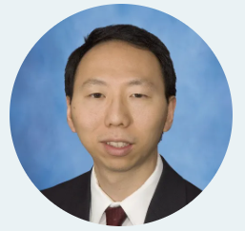

Jules Lin, MD, FACS is a Professor in the Section of Thoracic Surgery at the University of Michigan and the Mark B. Orringer Research Professor. He is the Associate Chief Clinical Officer for the CV/Neuro subsegment. He has leadership experience with daily hospital operations, capacity management, and improving patient safety and quality. His leadership team was involved in the recent activation of the University of Michigan Kahn Healthcare Pavilion. He has expertise in establishing national guidelines as a member of the National Comprehensive Cancer Network (NCCN) Non-Small Cell Lung Cancer, Mesothelioma, and Thymoma Guideline Panels. He also leads the open lobectomy room for the Society of Thoracic Surgeons Resident Bootcamp. He specializes in general thoracic surgery and has an interest in minimally invasive approaches in the treatment of lung and esophageal diseases as well as lung transplantation. He is a site-principal investigator for the Thoracic Surgical Oncology Group and has an interest in clinical trials evaluating the use of targeted therapies in neoadjuvant treatment for early-stage lung cancer.

