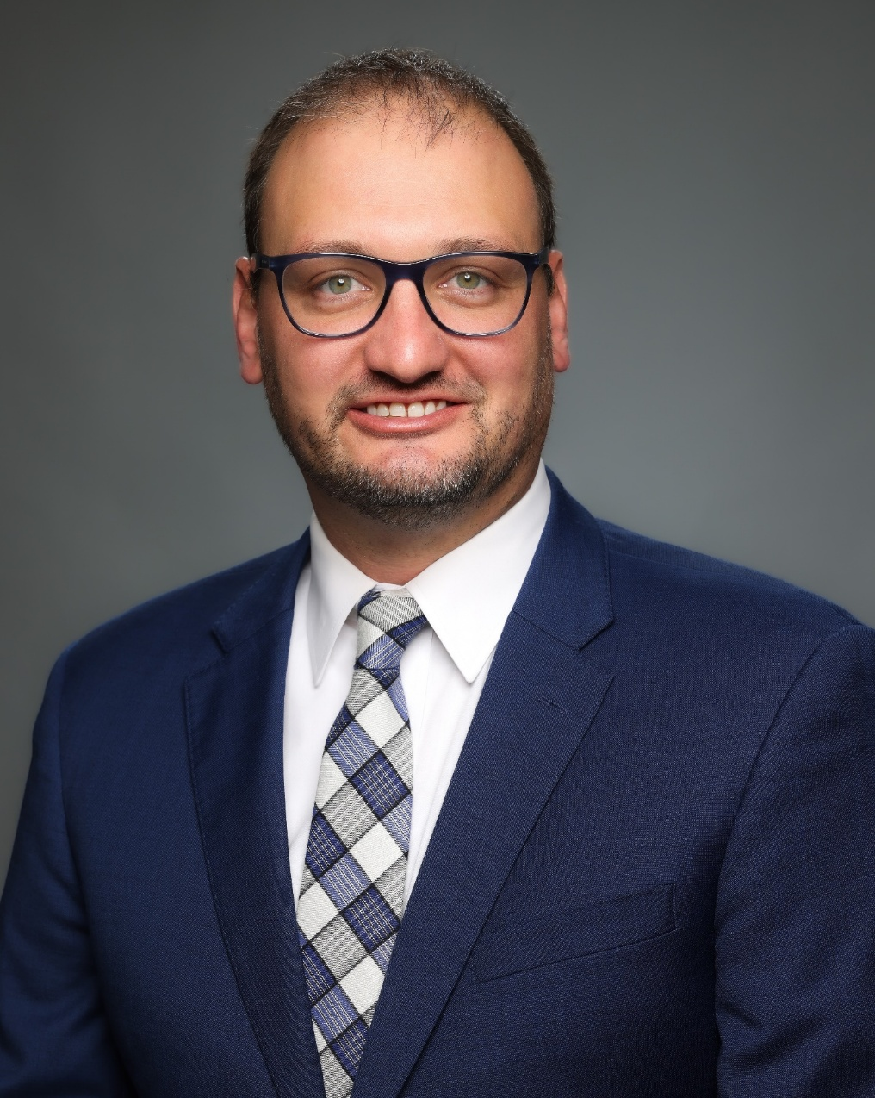
Lucas J Gross, PhD, MS, CNMT, RT(N)(ARRT), NMTCB(CT)(RS) – Lucas is a Practice Associate with the Radiation Safety Services at Landauer Medical Physics. He has earned credentials in nuclear medicine, computed tomography, and radiation safety. He has worked in various capacities related to radiation safety, education, therapeutic radiopharmaceuticals, and the administration of both ionizing and non-ionizing radiation. Dr. Gross has served as a director for nuclear medicine technology, computed tomography, and magnetic resonance programs. Additionally, he has served as a Radiation Safety Officer, overseeing research and a Veterinary clinic. Lucas is a proud member of the OSRT and serves on the Health Policy Committee. He currently serves on the SNMMI Technologist Advocacy Committee for Ohio, the Therapy Center of Excellence, the Committee on Radioiodine Theranostics, the Outreach Committee, and the Prostate Cancer Working Group. He serves as a Nuclear Medicine Chapter Delegate for the American Society of Radiologic Technologists (ASRT) and recently completed a grant with the Department of Energy. He has served with the ARRT on the Nuclear Medicine Technology (NMT) practice analysis and CQR advisory committee, the NMT exam standard-setting committee, and the NMT exam committee.

