DR. FRANCES JEFFRIES HONORED FOR ROTARY ACTIVITIES

Dr. Frances Jeffries, member of the Rotary Club of the Bridgewaters, is the 2024 recipient of the Dr. Percy Hodgson Memorial Award from Rotary District 7950 (SE MA, RI, Cape and Islands).

This award was established in recognition of the late Dr. Percy Hodgson’s leadership, assistance to others and service above self as District Governor, Rotary International Director and Rotary International President.

This year’s recipient, Dr. Frances Jeffries, joined Rotary International in 1987, first in Turlock (CA) Club, and later, the Bridgewaters (MA). In 2010-2013, she was a member in Chesterfield and Clayton Ladue (MO).

Her Rotary activities include:
Club President
District 7950 Peacebuilding and Conflict Prevention/Resolution Committee
District 6060 Visioning Team, Literacy Coordinator
Rotary Action Group for Peace, Nuclear Weapons Education Subcommittee
Civil Society Observer for UN events
Convener, Rotarians for a World Free of Nuclear Weapons
Cadre of Technical Advisors
Rotary Volunteer
Proposal Review, Project Monitor, RI 3-H project, Literacy in South Africa, KwaZulu-Natal, South Africa. She served that project as a Rotary Volunteer (2000, 2004, 2008, 2010) assisting with staff and organizational development, and organizing the first adult literacy information exchange to be held in Africa. Jeffries is also project coordinator for the Vocational Training Team Global Grant in the same region focused on family literacy. She was Rotary Volunteer at Tigray Development Association, Mekelle, Tigray, Ethiopia (1996, 2002). She assisted the Water for Cambodia project (2002).
ShelterBox Ambassador, 2008-present
Institute for Peace and Economics Representative, 2017-present
Rotary Peace Fellow, Professional Development Program, Chulalongkorn University (Thailand), January-March 2016
Civil Society Observer, United Nations events related to nuclear weapons, 2019-present

In the Bridgewater community, where she has lived since 1997, she has served on the School Study Committee, the Board of Registrars, and as a Library Trustee. She actively supported youth sports activities in the community, especially soccer and basketball. Jeffries is leading the International Cities of Peace Committee for the Town of Bridgewater and is a member of Bridgewater Communities for Civil Rights. She is a member of the Christian Science Society and has served as a Reader for the church and in the Bridgewater State Hospital.

Jeffries focuses on bringing vision to organizations, linking them to larger contexts, building infrastructures and systems, and optimizing resources, while incorporating her knowledge of how people learn, communicate and change to facilitate sustainable outcomes. She is pro bono consultant to non-profit organizations for peace initiatives especially focused on the total elimination of nuclear weapons.

She completed a Ph.D. at Kent State University (OH) and has worked in all types of educational settings, as well as in several community-based organizations. She has shared her home with nine children.

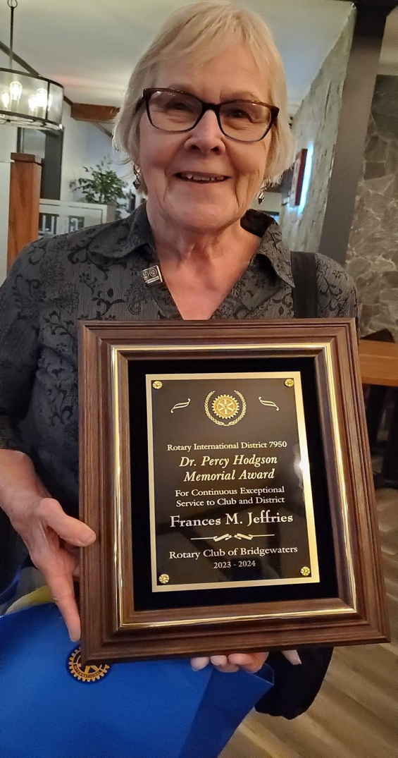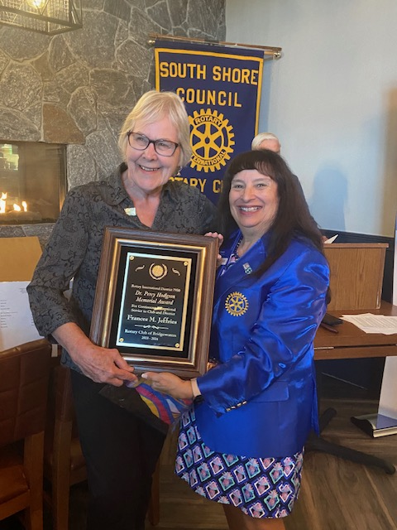

Left: Frances Jeffries
Right: Frances Jeffries and District Governor Angela Ponte

