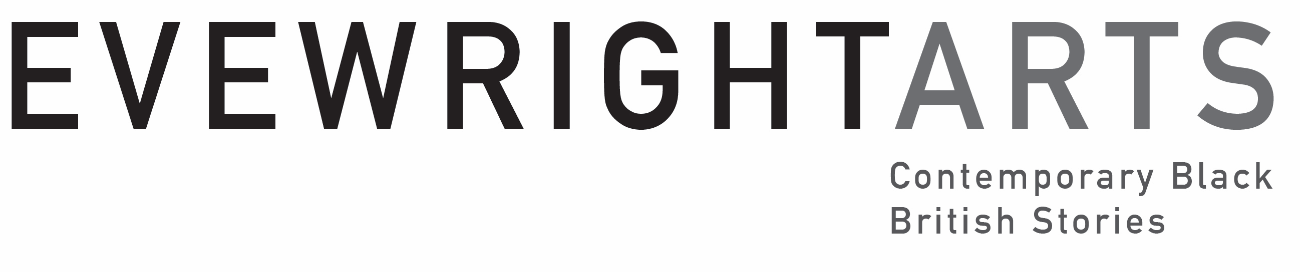

Unbroken

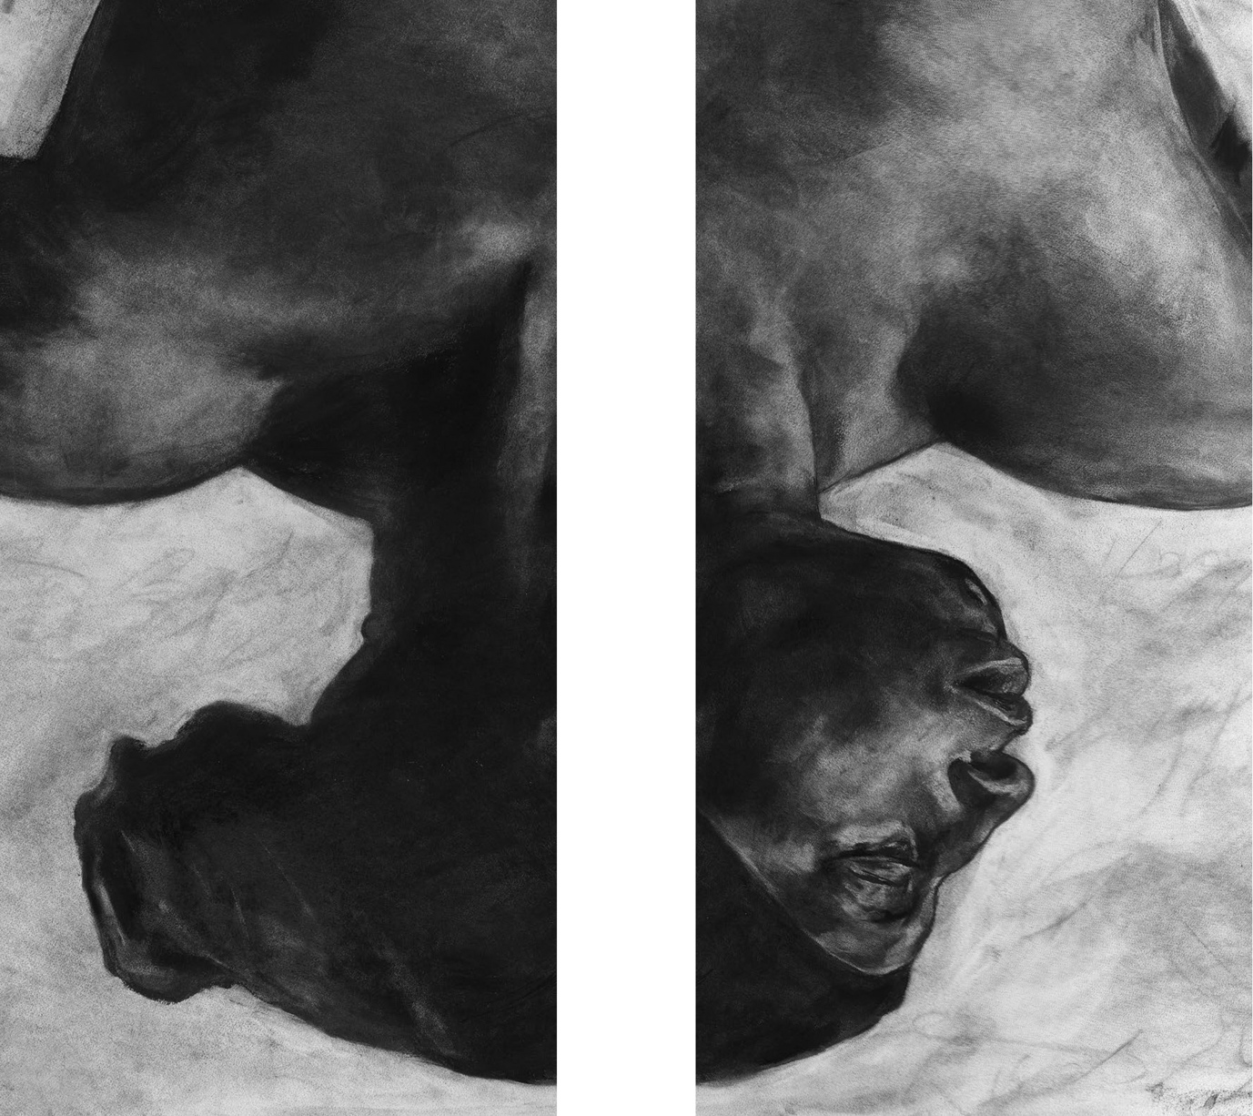

EVEWRIGHT ART’S CURATED ART INSTALLATION UNBROKEN OPENS IN OCEAN COURT AT THE NATIONAL MARITIME MUSEUM, GREENWICH.

(29TH NOV 2025- 15TH FEB 2026)

Evewright Arts joined the National Maritime Museum’s (NMM) Practitioners-in-Residence for a 5-month residency from July–November 2025 to explore the theme of ocean justice. This innovative residency includes co-founders EVEWRIGHT, a visual artist and Ionie Richards, writer and poet. This residency, culminating in 2025, is part of celebrating the re-opening of the museum’s environmentally enhanced central ocean court.
Unbroken, is an Evewright Arts curated, Artists response to the massacre of 133 enslaved African people by the crew of the British slave ship Zong in 1781.

Artist EVEWRIGHT creates a stunning art installation on 16 large banners that spans Ocean Court along with poetry from Ionie Richards. In Unbroken, EVEWRIGHT reimagines the Museum’s naval uniforms alongside a previous sculptural series,
£££ Kissi Penny $$$, named in reference to an iron currency used during the trade of enslaved people in West Africa. The artist explores the theme of ocean justice to create an artwork of potent juxtaposition that exposes the intersection of value, humanity and institutional complicity in the transatlantic trade of enslaved African people.

Artist EVEWRIGHT said:

‘I discovered the ship’s log for the British slave ship Zong within the Maritime Museum’s archive collection. Unbroken was created as an emotional response to the murder of 133 enslaved Africans thrown overboard for the sake of an insurance claim. The one ‘Unbroken African’ who fought to survive by climbing back on board the vessel, however, was thrown back into the sea.

‘My work is an active, ongoing dedication to him and his struggle, which is unequivocally the fight of the Black British people in the UK today. Unbroken is not merely an artwork; it is a lament, a challenge, and a demand for institutional accountability, built upon the enduring strength of a man who refused to be broken…’forever climbing back on boarding.’’’

The installation includes a curated visceral atmospheric visual and sound storm scape with poetry. EVEWRIGHT’s artwork is also interplayed with a poem on a banner, Laying the Burden by Ionie Richards who said:

‘I used poetry to create a dialogue, and reverence within the space, a homage to the 54 women and children thrown overboard on the Zong as part of the 133 African people murdered. Laying the Burden along with other poems from my collection seeks to highlight the inhumanity of the ocean journey of those trafficked and enslaved.’

Sarah Lockwood Head of Engagement at the National Maritime Museum said:
‘Royal Museums Greenwich is proud to present Unbroken, a powerful new art installation created collaboratively by Evewright Arts, in response to a 5-month residency interrogating the museum’s collections through the lens of Ocean Justice. This new work embodies the complex stories that can be told through museum objects and archives, centring human resilience and the honouring of ancestors in this creative response to the tragic events on board the British slave ship Zong.’

Unbroken: Opening Evening

29th November 2025
Time :6-9pm
Location: Ocean Court National Maritime Museum

To Book Tickets click

https://tickets.rmg.co.uk/webstore/shop/viewItems.aspx?cg=RMG&c=NMMEV#13989
On the opening night Artist EVEWRIGHT’s stunning art installation will be on display on banners in Ocean Court along with poetry and a performance by Ionie Richards. An artist talk and Q&A will be hosted by Maritime Museum’s curator Victoria Lane.

To honour the ancestors and the 133 enslaved African people who lost their lives over
3 days on the Zong from the 29th November 1781, a Libation dance ceremony would be performed during the opening event by Dr ‘H’ Patten, MBE, and Peter Badejo MBE along with musicians. ‘H’ and Peter are two of the UK’s leading African dance practitioners. This unique ritual will contribute to an immersive and moving experience.

END

---------------Notes to Editor----------------------------------------------------

Evewright Arts, Evewright Arts Foundation (EAF)
is a not for profit organisation that is passionate to seek out, find and preserve untold Black British stories from the diaspora using multidisciplinary arts and storytelling. EAF value the importance of their community telling their stories in their own voice.
Evewright Arts joined the National Maritime Museum’s Practitioner-in-Residence for a 5-month residency from July–November 2025 to explore the theme of Ocean Justice. This innovative residency, culminating in 2025, is part of celebrating the re-opening of Ocean Court, which puts the theme of the ocean at the heart of the museum.
Royal Museums Greenwich
The National Maritime Museum holds the world’s largest maritime collection, telling stories of Britain’s relationship with the sea. It is part of Royal Museums Greenwich which also incorporates the 17th-century Queen’s House, Royal Observatory Greenwich and the famous clipper ship Cutty Sark. This unique collection of museums and heritage buildings form a key part of the Maritime Greenwich UNESCO World Heritage Site and is also a major centre of education and research.
The mission of Royal Museums Greenwich is to enrich people’s understanding of the sea, the exploration of space, and Britain's role in world history. For more information, visit www.rmg.co.uk
EVEWRIGHT

An acclaimed multidisciplinary artist, EVEWRIGHT's work champions Black British stories, prompting dialogue about what it means to be Black and British in the UK today.

EVEWRIGHT Is also concerned with socio-political issues of place, space and the movement of peoples. He explores film, storytelling in relation to drawing and his practice goes beyond the decorative and the 2D, employing drawing as a documentary tool to give voice to hidden stories and hidden peoples.
See biography for further information. https://evewright.com/biog
£££ Kissi Penny $$$
£££ Kissi Pennies $$$ were originally made from iron rods and were initially used with the slave trade in 16th Century West Africa as a currency that echo Benin bronzes and were associated with spirits of the deceased. The decorative pieces taken from items of Dutch furniture make-reference to the Dutch slave trade. Between 1596 and1829, the Dutch transported about half a million Africans across the Atlantic. The Zong was originally a Dutch slave ship the Zorge captured by the British in 1781 and renamed The Zong. During this period an estimated 3.4 million Africans were transported on British ships.

The inspiration for the sculptural coins on the banners came about when Artist EVEWRIGHT bought two ready-made objects found in street markets in different continents of the world. An Afro-comb bought in South Africa and18th and 19th century-style Dutch furniture ornaments from Amsterdam. The Artist casts them into plaster moulding, breaking the motifs and ornate handles of the traditional style afro-comb into elements, he then re-assembles them to create new abstract forms and objects which are highly symbolic. They become a cultural lexicon of fragments ready for the development of new characters and new narratives. The artist re-names these objects £££ Kissi-Pennies $$$.

Ionie Richards

Ionie Richards Is a Black British writer, poet and filmmaker from London UK. She is also co-founder of Evewright Arts Foundation (EAF). In her writing and thinking; her themes have always explored the economic social and political underbelly of society speaking about the underclass, migration and giving voice to the disposed.

Ionie’s poems in the installation took inspiration from Drawing the Black Body a life drawing class, hosted by EVEWRIGHT at the National Maritime Museum in October 2025. The session was specifically designed to introduce a positive representation of the Black body into an institutional setting at Ocean Court for the first time, actively working to challenge and rebalance its negative societal perception.

Libation
Libation is a ceremonial pouring of a liquid to honour ancestors, a spiritual ritual prominent in traditional Black Caribbean and African cultures. The ceremony will be performed by
Dr H Patten Phd., MBE https://isrf.org/people/h-patten and Peter Badejo MBE
Choreographers, performers and dance specialist along with their musicians, Nii Kwartey-Owoo and Charles James.

For more information
Contact: hello@evewrightstudio.com
Studio 204, High House Artist Studios, Artisan Way, Purfleet-on-Thames, Essex, RM191AS. UK | Tel: +44 (0) 8450 542 305

Website and social media Websites

https://www.evewrightarts.org
https://evewright.com
https://www.ionierichards.com
INSTAGRAM:@evewrightarts
INSTAGRAM:@evewrightstudio.com
INSTAGRAM:@ionierichards
X /Twitter @evewrightstudio
FACEBOOK :https://www.facebook.com/evewrightstudio

Media images:
A selection of media images can be found here: https://www.dropbox.com/t/FVbDkIM8m0XWxair
UNBROKEN is open to the public at the National Maritime Museum, Greenwich

Information for visitors:
Venue: Ocean Court, National Maritime Museum, Greenwich
Date: Opening Launch – Saturday 29th November 2025
Time: 18.00 – 21.00
Admission: Free (booking required)
To Book Tickets click here:
https://tickets.rmg.co.uk/webstore/shop/viewItems.aspx?cg=RMG&c=NMMEV#13989

Date: Sun 30th November – 15th February 2026
Time: 10:00 - 17:00
Admission: Free ( No booking required)
Visitor enquiries: 020 8858 4422
X/Twitter: @RMGreenwich
Instagram: @royalmuseumsgreenwich
Facebook: @royalmuseumsgreenwich

Images:

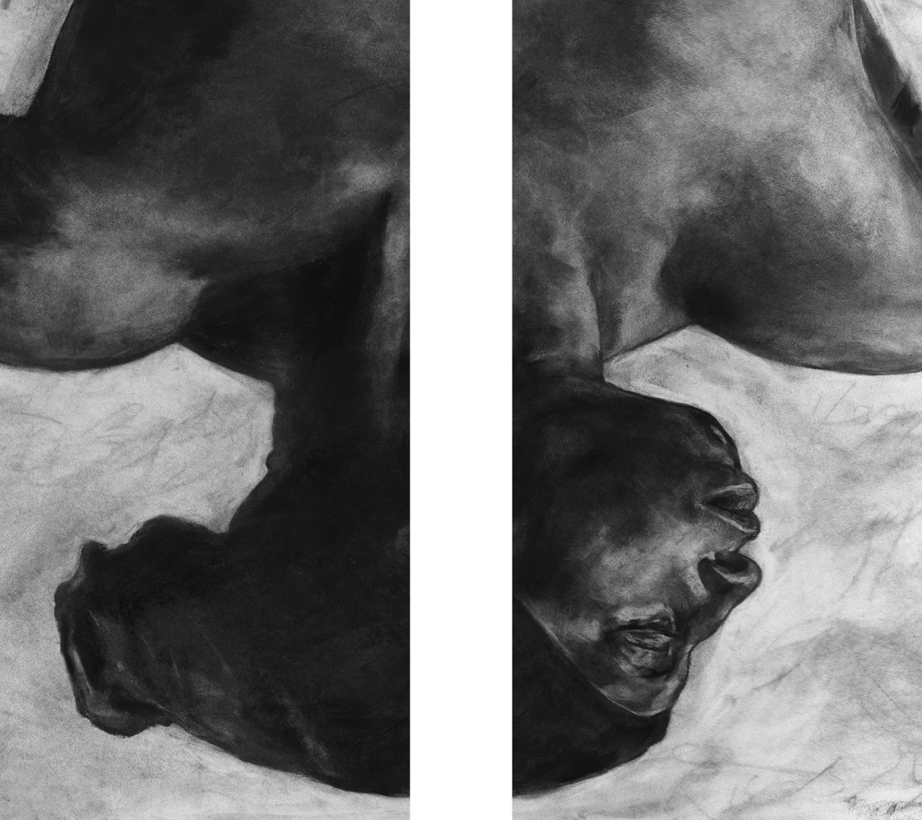

© 2025. EVEWRIGHT. Title: In(voice). (Banner section) Height 400 x Width 400cm.
Materials: fabric. Evewright Studio all rights reserved 2025.

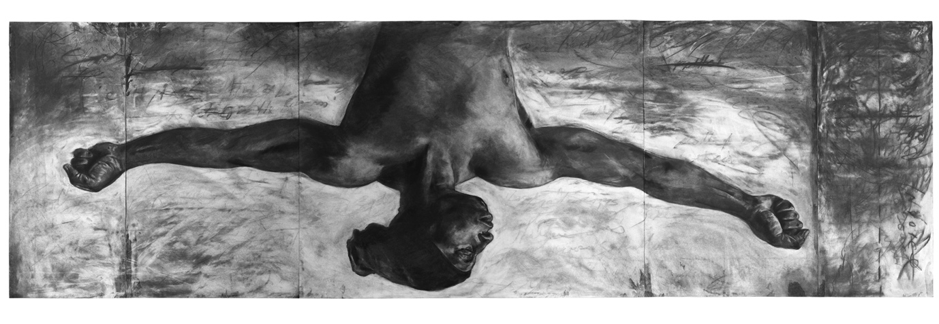
© 2025. EVEWRIGHT. Title: In(voice). Drawing: Height 122 x Width 405cm
Materials: Black Charcoal. Evewright Studio all rights reserved 2025.

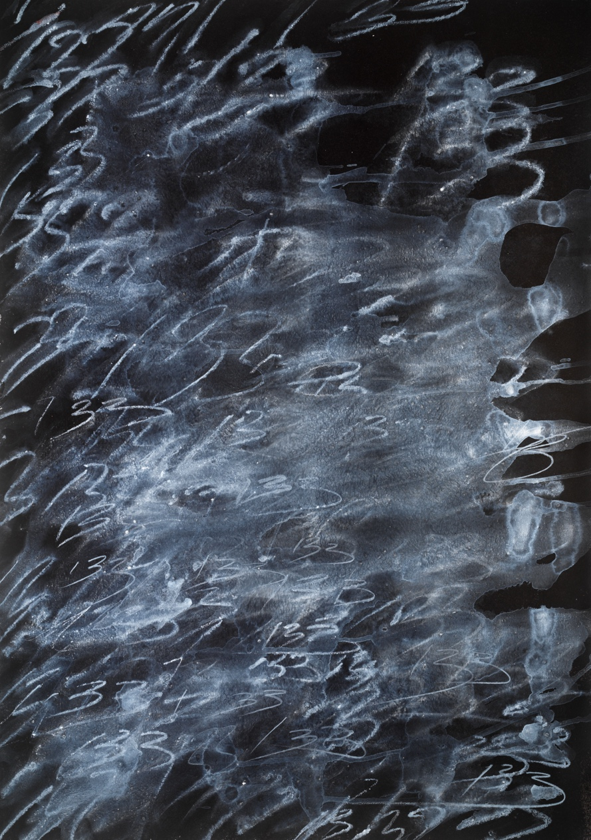

© 2025. EVEWRIGHT. Title: 133. Painting: Height 90 x Width 60cm.
Materials: Acrylic. Evewright Studio all rights reserved 2025.

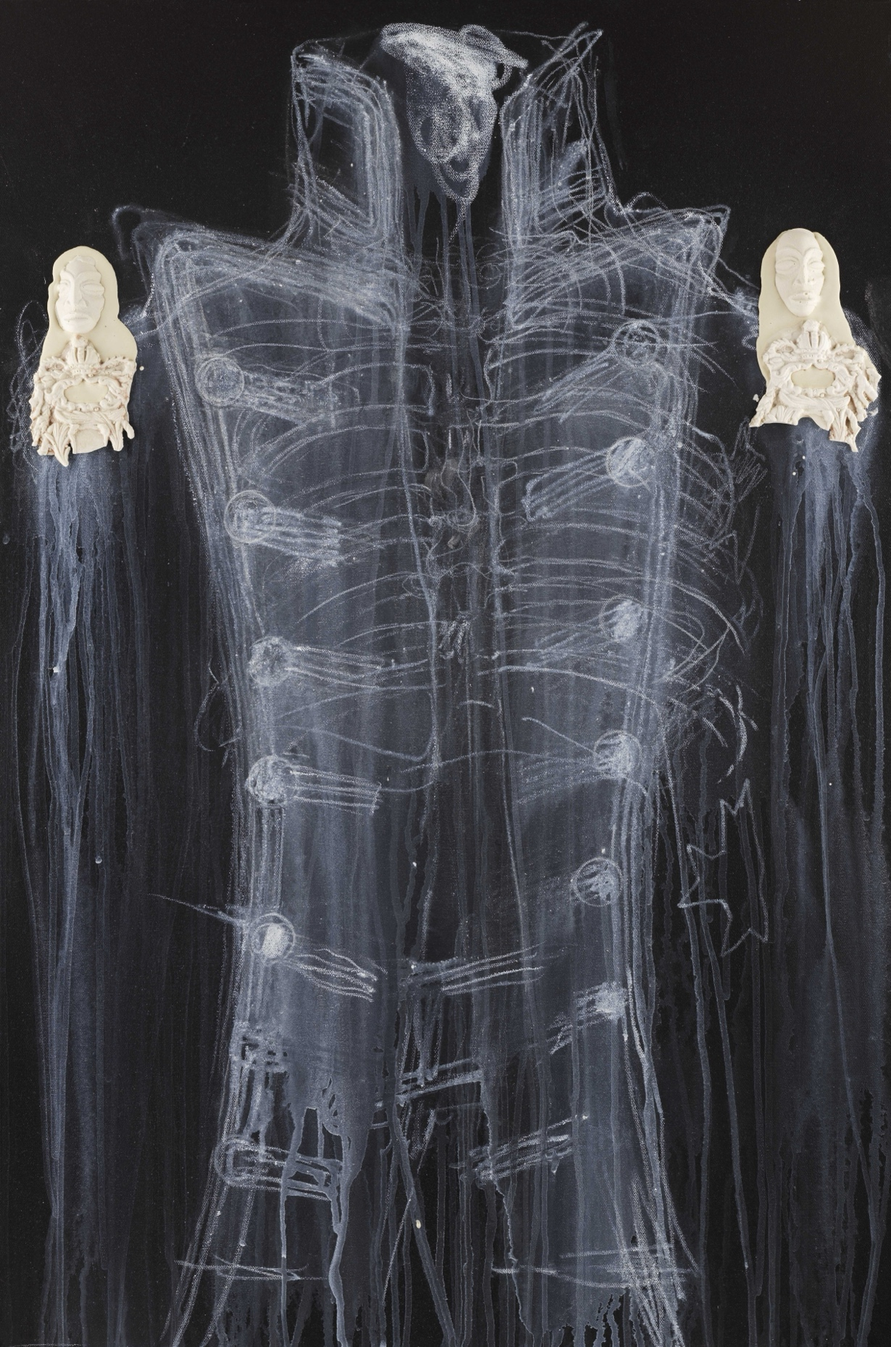

© 2025. EVEWRIGHT. Title: £££ Kissi Penny $$$. Horatio (I). Painting: Height 90 x
Width 60cm. Materials: Acrylic, Plaster Polymer. Evewright Studio all rights reserved
2025.

