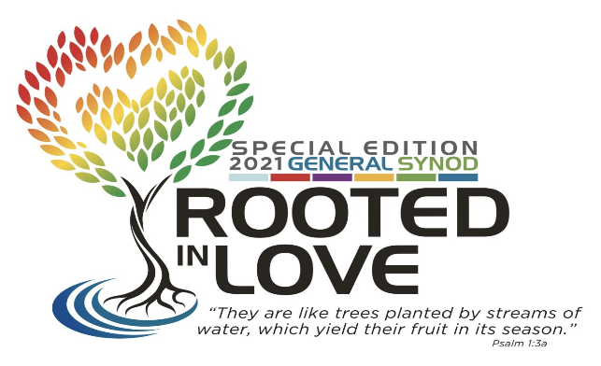

UNITED CHURCH OF CHRIST
ANTOINETTE BROWN AWARD NOMINATION

General Synod 33
Online ~ July 11-18, 2021

Celebrating the life and ministry of Antoinette Brown and all women in ordained ministry

Nominees for Trailblazers should be ordained clergywomen in the UCC who honor Antoinette Brown’s vision of women in leadership in church and society. Nominees for Catalysts are projects, collectives, congregations or organizations that serve as provocative places that advance and empower women in ministry.
€ Trailblazer
€ Catalyst

Use additional pages as needed. Supporting documentation, as well as letters of support, should be attached to this form or as email attachments.

Name of nominee:

Full address of nominee:

Year ordained (Trailblazer) or founded (Catalyst):

Present ministry:

Antoinette Brown was a pioneer who worked to advocate for women's leadership in church and society. How does this nominee carry on that spirit in their work?

Briefly share the nominee’s major accomplishments:

Add any further comment you wish to make about the nominee:

Person submitting the nomination:

Contact information:

Please email this form, no later than March 15, 2021, to
Rev. Tara Barber
Minister for Ministerial Support and Accountability
United Church of Christ
700 Prospect Ave, Cleveland, OH 44115
barbert@ucc.org; 866-822-3840

