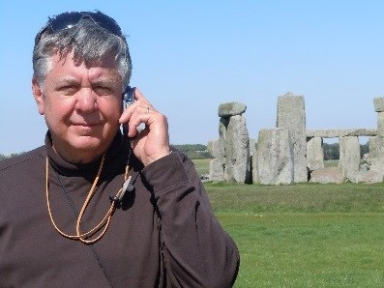
In June of 2016, a resolution was passed at the Conference Annual Meeting to have an Annual Offering taken in the congregations of Penn Central Conference to benefit the programs, especially the summer programs of Hartman Center. We didn’t take up an official offering in 2017 because of the special appeal and support given for the new swimming pool (over $70,000 was given by individuals, congregations, and Associations). We decided that the 2018 offering would be taken on the Sunday (February 11) before Valentine’s Day. We wanted it to be A LOVE OFFERING.
Here are just a few of the things I LOVE about Hartman Center. I hope you or someone you know has a list of their own.
- I LOVE remembering the first time I directed a Labor Day Family Camp back in 1982.
- I HAVE LOVED hiking the knob over the years especially with children and youth that couldn’t imagine ever making it to the top of the mountain.
- I LOVE the memory of sleeping out in the pines, or by the pond, or on the O-deck.
- I HAVE LOVED watching my own children growing up attending camp, first as campers; then as counselors; and then as an SST.
- I LOVE remembering Confirmation Retreats over the years with creative ways of learning what it means to be a church.
- I LOVE rafting on the Juniata River and, in recent years as co-director of Fishing Camp with Mike Landis, fishing on the Juniata and hearing a camper cry out “fish on”.
- I LOVE memories of Hamilton Park Church retreats at camp. Youth retreats and Women’s Retreats (I was never invited to them.)
- I REALLY, REALLY LOVE being able to take our four grandchildren to camp.
- I LOVE the Hartman Center Golf Outing and the Fall Festival.
- I LOVE that Hartman Center is being managed by UCCR (United Camps, Conferences, and Retreats) and that they are helping us encourage lots of other groups to use the camp.
- WHAT’S NOT TO LOVE about the people (campers, directors, volunteers, SSTs, and nurses) who make it all happen at camp, year after year.
- FINALLY, I LOVE people in our Penn Central Congregations willing to INVEST in one of the very special ways that God touches the lives of people of all ages.

THANK YOU for supporting the ministry of Hartman Center and for receiving the 2018 LOVE OFFERING on February 11.

We hope you enjoy this year’s Summer Camp Brochure sent out to all the churches. And if your church is scheduled to have a visit on February 11 as part of the BIG SPLASH #2….thanks for your support. We hope to see you at camp sometime soon!

Dave Bushnell, Hartman Center Advisory Committee

