In response to the United States pulling out of the Paris Climate Accord, General Synod passed an emergency resolution entitled “The Earth Is the Lord’s—Not Ours to Wreck” with a 97% affirmative vote of the delegates. The General Synod Resolution “The Earth is the Lord’s – Not Ours to Wreck” lifts up the urgency of caring for God’s endangered creation. As we attend to sustaining creation, let’s keep in mind the Christian conviction that God sustains the creation.
Far from meaning that we don’t need to be concerned about the present crisis, this means that when we wreck the earth we are working directly against God’s work, which includes sustaining creation. So we need to repent for the wrecking we have been doing.
Questions we need to ask ourselves might include:
Has our lack of faith that God will sustain us by providing what we really need led us into consumerism?
How can we open our eyes to ways in which advertising entices us?
Could reliance on God’s sustaining work help us to more joy in working for our environment?
Might it protect us from anxiety and discouragement?

Some UCC churches are giving further expression of commitment to Creation Care and concern about the Paris Climate Accord including the following actions:
Plant a Yard Sign for the Paris Accord
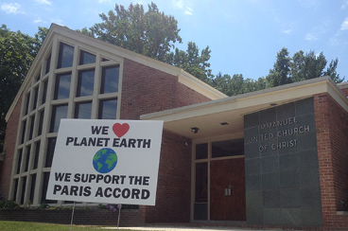
As a tangible act of witness, churches are invited to plant yard signs that declare, “We [heart] Planet Earth. We Support the Paris Accord.” The graphic for the sign can be downloaded along with a sample press release. Check out this article about one UCC church which has planted the sign

Preach and Teach
Encourage your pastor to preach on creation care and the truth about climate change and the moral imperative for people of faith to engage and act. Sunday School curriculum, book discussions and movie nights are other actions to share ideas, build a knowledge base and create fellowship. Resources at UCC.org/environmentalministries. UCC Environmental Justice Resources for research.

Also. just published this summer, Sustaining Creation – A Faith Journey for Small Groups is available directly without charge to individuals and faith communities everywhere at the website www.sustainingcreation.org or DVD sets are available by contacting terrenceggallagher@hotmail.com Blessed Tomorrow ‘s resources would be an option.
PCC UCC Contact: Bill Rader (crader@ezonline.com)

Join PA Interfaith Power and Light
Pennsylvania Interfaith Power & Light is a community of congregations, faith-based organizations, and individuals of faith responding to climate change as a moral issue, through advocacy, energy conservation, energy efficiency, and the use of clean, renewable energy. They have events state wide and provide speakers, resources and encouragement.
PCC UCC Contact: Bill Lochstet (bill.locht@gmail.com)

First Steps for Churches
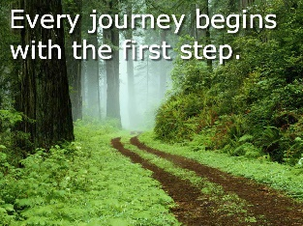
If your church is looking to gain a renewed sense of mission and purpose through an environmental ministry, try one of these first steps: Five Potential First Steps: Starting on the Path to Green Vitality Link: http://www.ucc.org/starting_on_the_path_to_green_vitality

Does your church want to make more of a commitment?
If your church has already taken some first steps but wants to ramp up its commitment, check out the Creation Justice Churches Program of the UCC. This is a new national designation for UCC churches. It asks churches to covenant to take Six Steps for environmental justice and creation care in their locale; to raise their awareness of justice issues at home and around the world; and to choose actions to take. Each congregation chooses actions that use their particular gifts, interests, and energy, and that serve their community. Check it out at www.ucc.org/creation_justice_churches
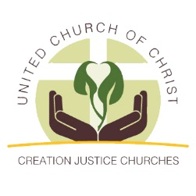
Penn Central Conference has two Creation Justice Churches to date: New Covenant UCC in Williamsport and Emmanuel UCC in York. Join in!
PCC UCC Contact: Gail Landers (planders102@comcast.net) and Libby Loser (lloser11411@comcast.net)

The next Green Justice Meeting is September 12 at Penn Central Conference Center Office at 10:00 AM. New members are always welcome. Please contact Tom Hocking at twhocking@gmail.com for additional information.

