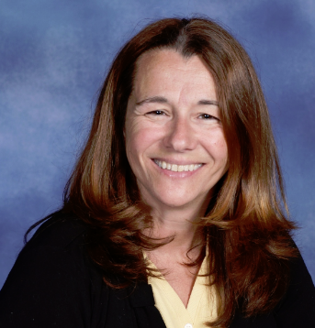What I hope to be remembered for . . .
To conclude each of my ministry settings, I have preached a sermon titled, “What I hope to be remembered for” (and included, “What I hope you will forget”) and so as I prepare to leave my position as the Conference Associate Minister for Congregational Life and Vitality at Penn Central Conference, I thought it most fitting to offer the following reflection.
I hope to be remembered as a facilitator on the conversation about growth. In this time in our history, it is important to answer questions like, “What is the purpose of church?” “What do we have to offer to the community?” and “What are people in the community looking for from a church?” Over the past 7 years, I have witnessed so many congregations engaging in an intentional process to answer these questions to be equipped to reach out to their communities in new and creative ways. Other congregations just wanted me to give them the “quick fix” approach to church growth and were frustrated when I gave them the long version. At the end of the day, transitioning from membership to discipleship is about spiritual transformation. Numerical church growth is never the goal but it can be an indicator that disciples are beginning to practice invitational ministry.
I was once asked by the board of directors, “How many of our churches do you think can grow?” and I answered, “All of them” (either that or I would have gone home a long time ago). I hope I will be remembered as one who could see the potential in every congregation, inspired confidence in the membership to dream big and fostered hope that the best days of mainline religion in Central Pennsylvania are before us, not behind us. I hope I will be remembered for my passion to convert seekers to Christianity and to assist Christians to put their faith into practice.
You should know that each of you has had a part in renewing my faith in Jesus and the future of his church. Thank you for your willingness to take risks, try new things and tweak ideas to work in your own cultural setting. Thank you for supporting me when I tried some new things at the conference, some which worked well, others not so well. I will remember fondly our times together at Clergy Leadership, the Ezekiel Project and the other Prophet Projects. I thank God for calling me to this position where I could reflect on how I went about spiritually and numerically growing congregations. When I first arrived here, no one had ever asked me just how I did this and it has taken me 7 years to figure it out.
I am ready to return to the parish ministry and have accepted a call as the Lead Pastor at Christ Church in Bethlehem PA. It has been an honor serve among you.
Laurene Beth Bowers

