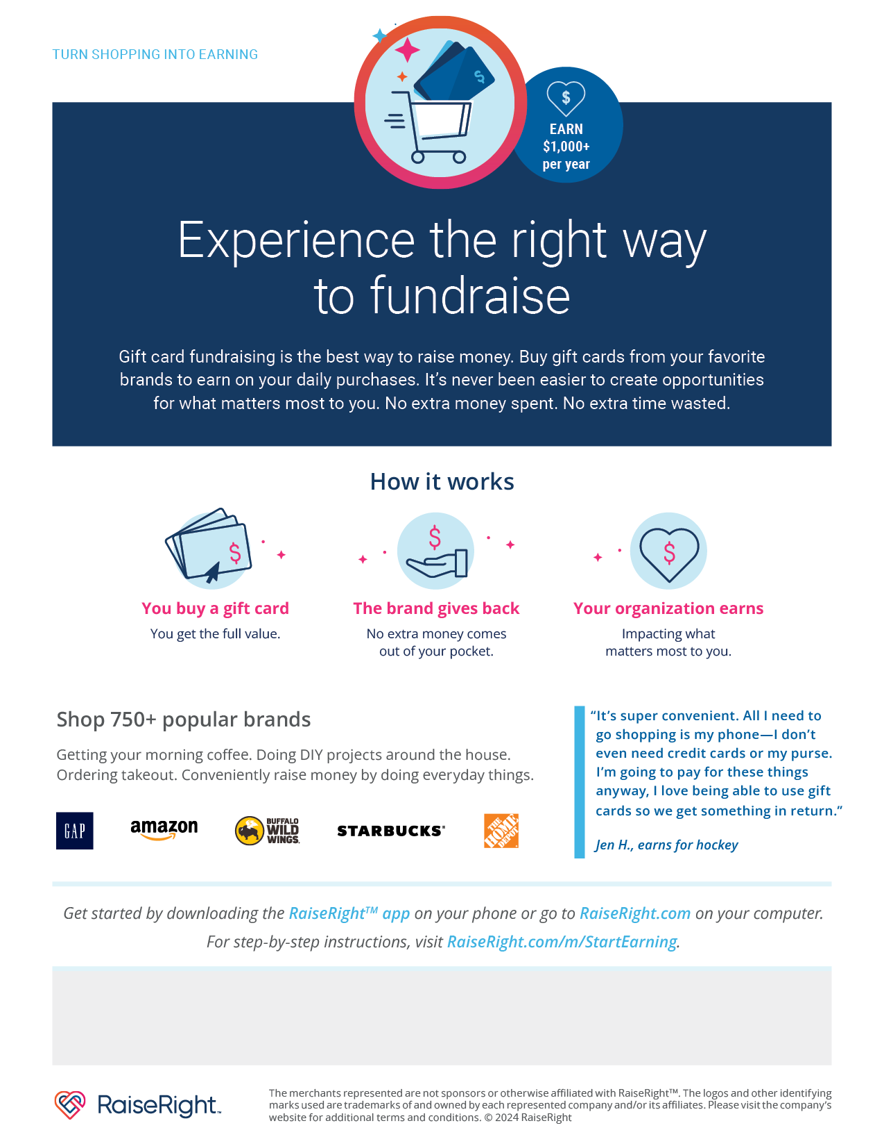
The enrollment code for Sugar River is 5AA78F3A24231

