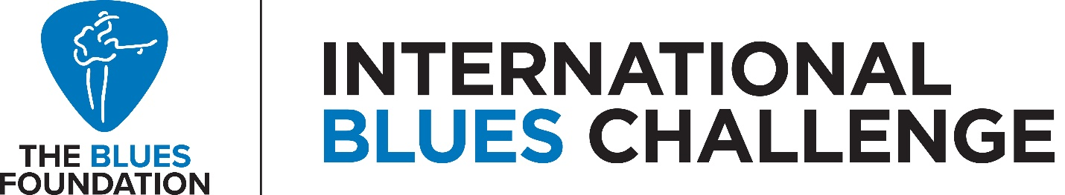

Expanded Rules for 2020/2021 Local Blues Challenges

The rules as they are currently written remain in effect for this coming year with an expanded opportunity to hold a virtual event should a live event be impossible due to the coronavirus pandemic.

Any Blues Foundation affiliated blues society may still hold a live judged event in its community if it is allowed to do so under its local COVID-19 gathering rules and if it so chooses, in accordance with the current IBC rules applicable to live challenges. Individual blues societies may determine social distancing rules, requirements for masks, and other protections as needed and as required by its local COVID-19 gathering rules. Live challenges may also be held without audiences present or streamed to audiences by the affiliate. In this scenario, judging must happen live and in-person in the venue, and not over streamed content.

Should an affiliated blues society be unable to hold a live judged event it may choose challengers via video submissions by the challengers, with the following protocols required:

- All performances must be pre-recorded and distributed to judges for review and scoring. Streaming is not allowed to ensure consistency for judging purposes.
- Performances must be filmed single view with one camera, landscape/horizontal capture, on a cell phone. No professional video equipment may be used. Tripods may be used and are encouraged to ensure a stable picture.
- Performance must be continuous. Musicians may not capture and edit multiple takes.
- There may be no post-production edits or post-production elements added to the video.
- There may be no captions and no lower thirds added to video content. Content must be taped raw with no editing of originally captured content.
- The same judges must be used to score all submitted performances.

The manner in which the local blues community is engaged in viewing and supporting each local challenge will be left to the leadership of each affiliated blues society. The Blues Foundation encourages continued use of this event to support fundraising, bring in sponsors, build membership, and expand awareness of the blues within each community.

