We are looking for a 6th grade student's artwork that can be showcased on the covers of the 2024-2025 Ogden Avenue School yearbook. The theme is "We’ve Got Grit" and MUST include the Ogden tagline "Work Hard. Be Kind."

Contest kicks off Thursday, October 10th!
Final artwork will be judged on creativity, design and theme.

Artwork Submission Requirements:
- Yearbook Theme: "We’ve Got Grit" design with the tagline "Work Hard. Be Kind." included in the art work
- Must use 8.5x11 inch paper
- Must be portrait orientation
- Markers are preferred, but can accept crayons, colored pencils, or paint
- No stickers or chalk
- No digital art work
- Designs that portray positive, school related themes are requested

Contest Deadline is Wednesday, November 6th.

Please submit your artwork to your homeroom teacher in an envelope or folder marked:
“6th Grade Yearbook Committee - Cover Contest” by Wednesday 11/6

NOTE: The winner is kept a surprise until the yearbooks are distributed in the Spring!

Questions? Contact the Ogden Avenue School YEARBOOK COMMITTEE.
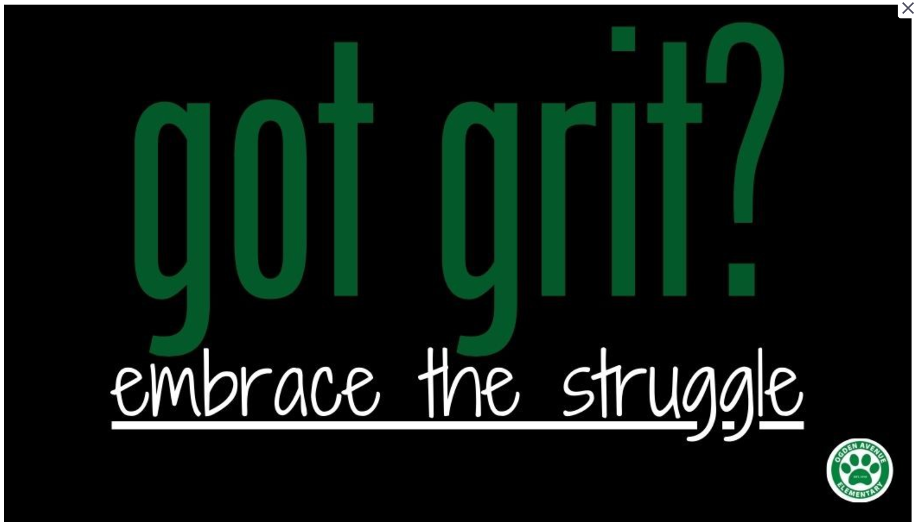
Why Grit Matters
- Builds Resilience: Life has its ups and downs, and students with grit learn how to bounce back when things don't go as planned.
- Improves Problem-Solving: By sticking with difficult tasks, students learn to find different ways to solve problems.
- Fosters Independence: Perseverance helps students take charge of their learning, instead of always relying on others for quick answers.
- Encourages a Growth Mindset: When students understand that challenges are part of learning, they are more willing to try new approaches and adapt.

- Key Words: perseverance, optimism, resilience, courage
- Give it your all, Redo if necessary, Ignore giving up, Take time to do it right
- The Power of Passion and Perseverance

