

October 22, 2024

The Greater Romulus Chamber of Commerce will be seeking nominations for the 38th Person of the Year.

The criteria for the nominees are individuals that have made significant contributions to Romulus and its residents.
Nominations will be accepted by the Greater Romulus Chamber of Commerce. A biographical synopsis should be provided stating reasons the nominee should be honored as the Person of the Year. There will be an award ceremony that will be held in Spring 2025.
The deadline to receive these nominations is December 12th, 2023. Anything postmarked and /or received after deadline will not be accepted. Nominations can be mailed, emailed, dropped off at the Chamber office, or submitted online using QR code below. Additional forms available at Chamber office.

11189 Shook Rd., Suite 200, Romulus, MI 48174 admin@romuluschamber.org

Nominations can be made by anyone. The person submitting a nominee must submit their telephone number or email address, so we may contact them. The nominee does not have to be a resident of Romulus, as long as they have made a contribution to Romulus.

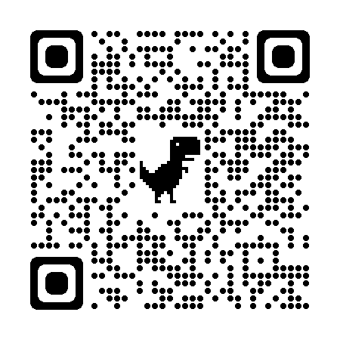
We are excited about this event. We look forward to receiving the nominations!! Sincerely,

Person of the Year Committee
Greater Romulus Chamber of Commerce

11189 Shook Road, Suite 200 Romulus, MI 48174 734.893.0694 admin@romuluschamber.org

Greater Romulus Chamber of Commerce

38th Person of The Year Nomination Form Please Nominate Any Individual That You Feel Has Made Significant Contributions to the Community of Romulus.

Nominee’s
Name

Nominee’s Occupation
List any service organization that the nominee is a member within the community

List the contributions, (non-monetary), that this individual has made to the community: Continue on a separate piece of paper if necessary.

Nominated by:
Name:________________________________________________ Phone Number:__________________________ Address:_____________________________________________ Email:______________________________________
_____________________________________________

The Chamber nominating committee will hold this information in the strictest confidence.
This form needs to be s submitted to the Greater Romulus Chamber of Commerce by December 15th, 2023.

11189 Shook Road, Suite 200 Romulus, MI 48174 734.893.0694 admin@romuluschamber.org

