FOR IMMEDIATE RELEASE
Contact: Ahoo Salem
Phone: 540-265-9339
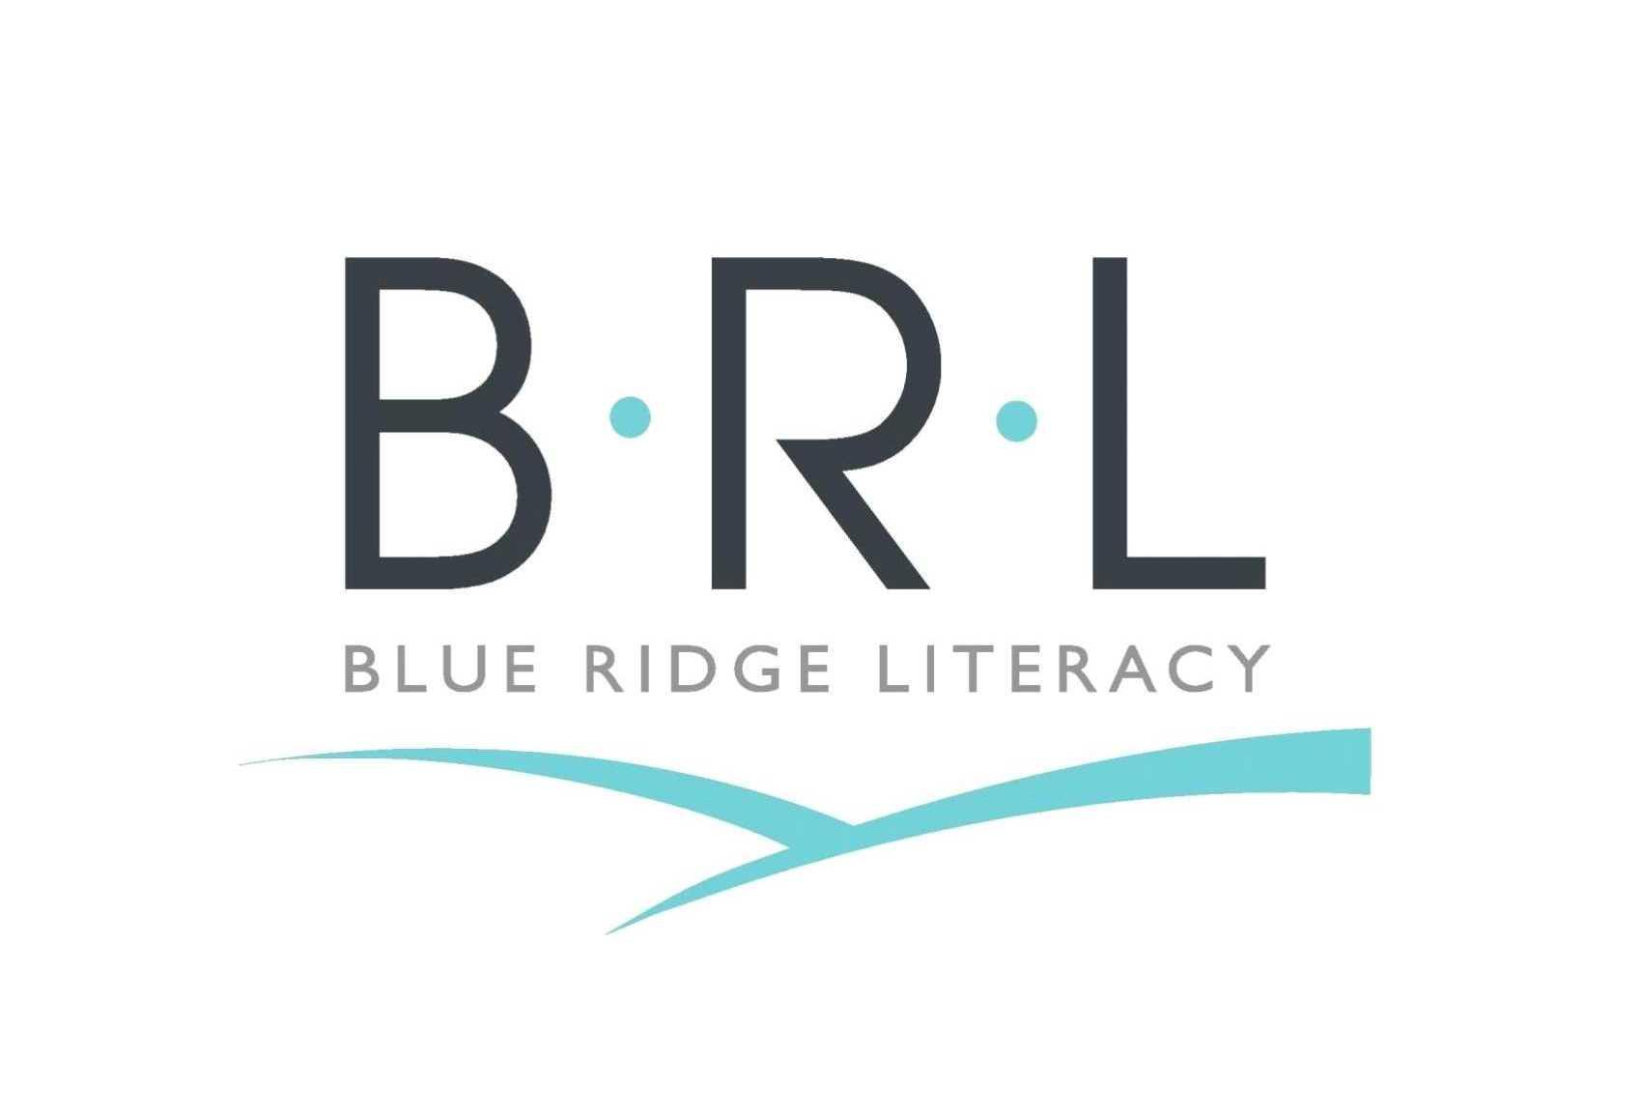
Email: asalem@brlit.org

Blue Ridge Literacy Receives Generous Grant From Roanoke Women's Foundation To Prepare Adult English Language Learners Transitioning Into Higher Education Settings.

November 8, 2023, Roanoke, VA — Blue Ridge Literacy is honored to receive $70,000 through Roanoke Women's Foundation's 2023 Grant Cycle. This grant is part of Roanoke Women's Foundation's recent award of $392,000 in transformational grants to support the needs within our community in the areas of Education, Health & Human Services, Arts & Culture, Education, and Environment.
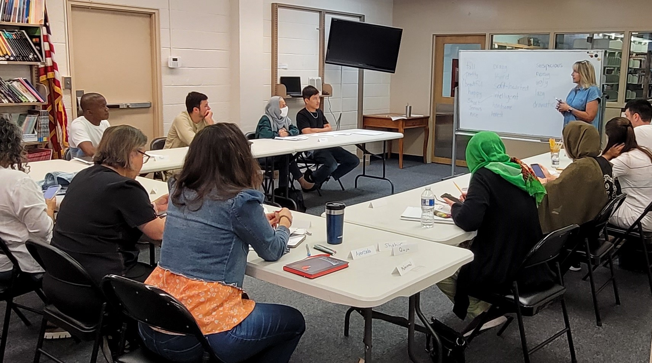
Roanoke Women's Foundation's grant will help establish “Pathways to Success: A Mentor-Supported ESOL Bridge Program” to Blue Ridge Literacy's English for Speakers of Other Languages (ESOL) curriculum. According to BRL's Executive Director, Ahoo Salem, "Blue Ridge Literacy has experienced an increased demand for ESOL services, serving 486 learners in FY 22-23, up from 365 in FY 21-22." Salem adds, "We have also witnessed a growing interest among learners participating in our Advanced-level ESOL classes to enroll in Virginia Western Community College. However, limited familiarity with the US higher education settings and academic readiness skills make the transition to community colleges more challenging for our learners." Pathways to Success will provide adult learners with the English proficiency, academic readiness, and mentorship support they need to transition and succeed in Community Colleges. As a collaborative project, the Bridge ESOL classes will include informational field trips to Virginia Western Community College and help familiarize adult learners with career pathways and certificate courses with a direct tie to the labor market.
Currently, BRL offers in-person and online classes at Pre-beginner, Beginner, Intermediate, and Advanced proficiency levels through three semesters year-round. Pathways to Success is a timely addition to BRL's services and is aligned with the organization's history of adapting its services to the English Literacy needs of adults in our community.
”The generosity of our member donors and their thoughtfulness in selection of the final recipients have once again highlighted the work of remarkable community non-profits.” said MaryJean Levin, President of the 2023 RWF Board of Directors. “This latest group brings our total to 96 projects funded, enhancing the quality of life for thousands in our local region.”

About Blue Ridge Literacy

Founded in 1985, Blue Ridge Literacy offers English literacy services to adults living in the counties of Roanoke, Botetourt, Franklin, Alleghany and Craig, and the cities of Roanoke and Salem. Last year, over 400 adult learners were served through ESOL programs, 1:1 tutoring matches, citizenship preparation and digital literacy classes. With a focus on functional literacy, BRL’s services equip adult learners with the skills they need to navigate everyday interactions and make long-term plans. Blue Ridge Literacy works closely with community partners to share information about available resources and opportunities in the Roanoke Valley. To learn more, please visit www.blueridgeliteracy.org. For questions, call 540-265-9339 or email info@brlit.org.

