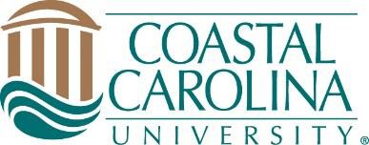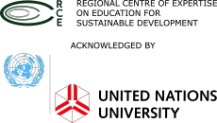

UN Youth Corps Internship Information
The RISE Center launched a local initiative to better prepare leaders of tomorrow in making smart and sustainable choices for the future. The UN Youth Corps Program is a high impact, transformative learning program centered on giving students real-life skills and professional experiences surrounding issues on sustainable development in Georgetown County. The effort supports a scientific/research-based perspective, while engaging a place for productive dialog and collaboration on sustainability, enabling a process for incubating student engagement and cultivation of professional talent, and encouraging participation and outreach related to sustainable development.

Sponsor Opportunities: The Youth Corps Program is generously supported by Partnership Grand Strand and Coastal Carolina University. Our interns have held positions across the county in a variety of areas, including marketing and communications, accounting, production, computer programming, decision support, sales, and more! For the upcoming term(s), we welcome public, private, and/or non-profit organizations in Grand Strand area to sponsor a student intern. It’s as easy as writing a short description and the skills required. CCU will do the rest: advertise, select top quality candidates, and provide all payroll services. Once sponsors commit to hosting an internship, the sponsor and student will be responsible for arranging the schedule and responsibilities, which will be documented and filed with Dr. Pamela Martin from CCU. Below you can find her contact information, as well as information on upcoming opportunity dates.
Upcoming Opportunity Dates:
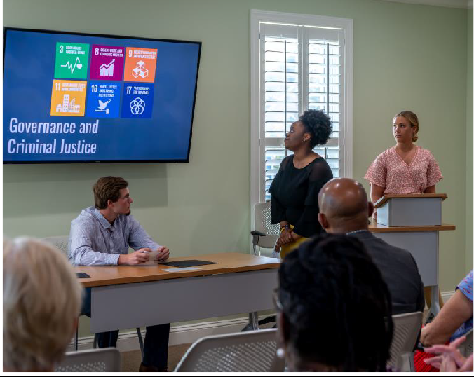

Summer 2025: May-August
$4,650 ($5,043 after fringe) per intern
Hours: 300 total hours/8 weeks for the summer at
$16 per hour.
*Sponsorships are available to offset internship cost by
Partnership Grand Strand.

Students receive 3 or more college credits for this
experience.

Please fill out this form to confirm your sponsorship of an intern and apply for grant funding: https://forms.office.com/r/MXDbahRqPx?origin=lprLink

Do not hesitate to reach out to Dr. Pamela Martin, director of the RISE Youth Corps program, with any questions. (plmartin@coastal.edu)

