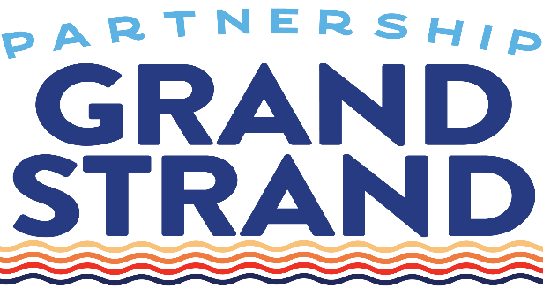
FOR IMMEDIATE RELEASE
September 4, 2025

Media Contact:
Marlane White
Myrtle Beach Area Chamber of Commerce
O: (843) 916-7295
Marlane.White@VisitMyrtleBeach.com

Partnership Grand Strand Announces Retirement of Peggy Masterson and Appointment of Ernest “BJ” Beaver as Interim Executive Director

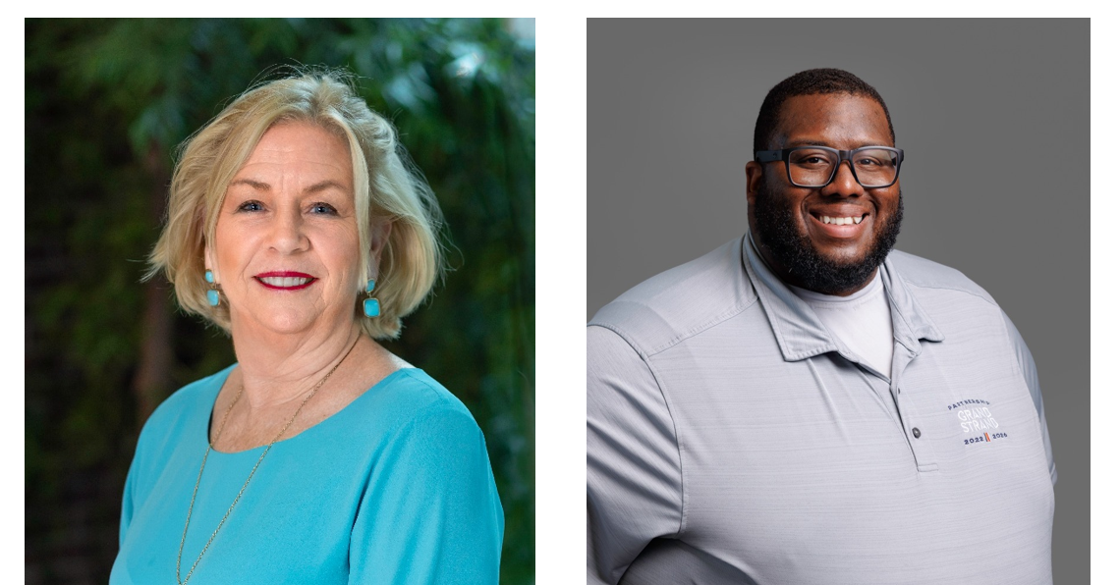
Pictured: Peggy Masterson (L) and BJ Beaver (R).

MYRTLE BEACH, S.C.—Partnership Grand Strand (PGS), the nonprofit foundation of the Myrtle Beach Area Chamber of Commerce (MBACC), today announced the retirement of Peggy Masterson, who has served as director since January 2023. The PGS board of directors has appointed Ernest “BJ” Beaver as interim executive director.

“During her tenure, Peggy has played a key role in advancing the foundation’s community work throughout the Grand Strand, contributing to initiatives designed to strengthen the region’s economy, workforce and overall quality of life,” said Matt Pivarnik, CEO of MBACC and Visit Myrtle Beach. “We are grateful for her many contributions and wish her the very best in retirement.”

Along with her tenure leading PGS, Masterson’s distinguished career includes more than 30 years in sales and marketing with organizations such as The Coca-Cola Company and serving as a senior living administrator.

Beaver has been with PGS since January 2023 as the business retention and development manager, where he advanced workforce initiatives and built strategic partnerships with local employers, community organizations and school systems. His contributions to strengthen the local talent pipeline include developing new programs for high school and college students such as summer leadership camps, scholarships and internships.

“BJ has consistently demonstrated himself to be a dedicated and effective leader,” Pivarnik said. “His expertise in workforce development, along with his ability to bring organizations together to build meaningful career pathways for our citizens, has been invaluable. These qualities make him exceptionally well-suited to guide the foundation during this transition.”
Beaver was named one of B2B: The Grand Strand magazine’s “2024 Best and Brightest 35 and Under,” and his professional development activities include membership with Grand Strand Young Professionals and graduation from both Leadership Grand Strand and the U.S. Chamber Foundation’s Business Leads Fellowship Program.
Along with being named a “2024 Change Maker” through Multiplying Good, Beaver gives back to the community as a board member with A Father’s Place, a family development organization in Horry and Georgetown counties, a board member with Conway Downtown Alive and mentoring students within Coastal Carolina University’s (CCU) Community and Business Engagement Institute.
Prior to joining PGS, Beaver managed academics and career services at Miller-Motte College in Conway and is a CCU alumnus.
###

About Partnership Grand Strand:
Partnership Grand Strand is a 501c3 foundation launched in 2022 by the Myrtle Beach Area Chamber of Commerce to fund a five-year community development initiative. Through investments from local businesses and partnerships with community organizations, the foundation leads and supports efforts related to four pillars of success: prosperity, talent, place and infrastructure. Through their focused endeavors, Partnership Grand Strand works to enhance quality of life across Horry and Georgetown counties. PartnershipGrandStrand.com

