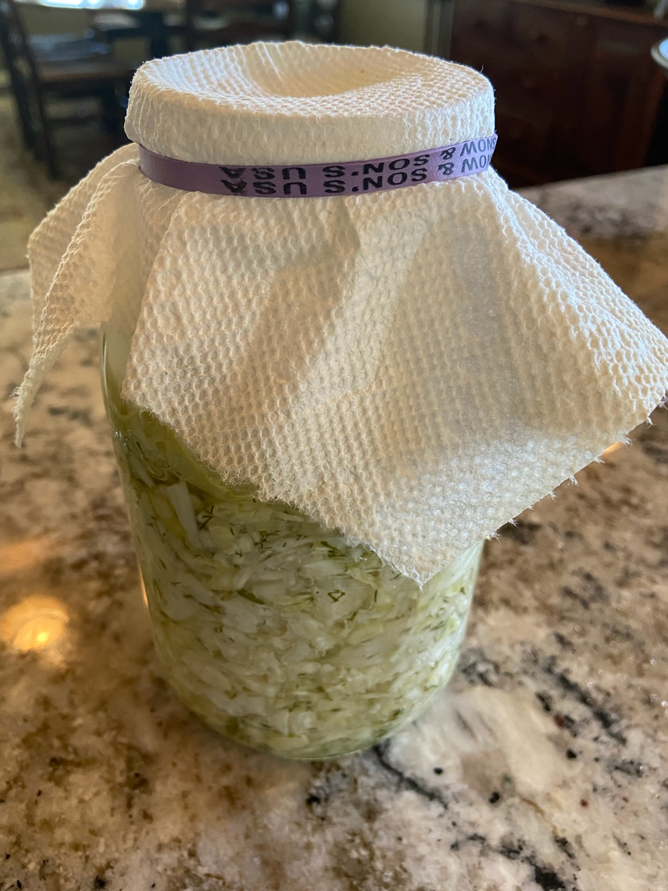

Sauerkraut in Mason Jars

If you’ve ever wanted to make your own sauerkraut, here is a super easy way to do it in your own kitchen!

Ingredients

1 head of cabbage
1 small package of dill - chopped (about 3-4 tablespoons)
3 cloves of garlic (minced)
Salt

Instructions
- Dice the cabbage into small pieces. I usually like to do this in a food processor so the pieces are very small. Save the larger outer leaves of the cabbage to use later.
- Once the cabbage is diced into small pieces, place it into a large mixing bowl.
- Add chopped dill, minced garlic and about 3 tablespoons of salt to the bow.
- Mix well.
- Once everything is mixed, add the ingredients to a mason jar. Pack each jar tightly and push down with each addition. Make sure to leave about 1 to 1.5 inches at the top of each jar.
- At this point, take the larger cabbage leaves and spread over the top of the mixture inside the jar. Make sure the leaves seal as much as possible of the chopped mixture into the jar.
- Now you want to put something on top of the large leaves to hold them down. I use small stones that you buy in the floral department of a craft store. I put them inside a ziplock bag, then place the bag inside the jar on top of the cabbage leaves. Pie weights, marbles or any small item with a bit of weight will do the trick!
- Once you have the weights in place to hold everything down, add water to the top of the jar. Add just enough so that EVERYTHING in the jar is underwater. Nothing should be above the surface of the water.
- Last step is to cover the lid with something to protect the kraut. I use a paper towel and secure it with a rubber band around the lid of the jar. This allow air to transfer but keeps everything else out!
- Now all you have to do is wait. I usually leave my jars on the kitchen counter for about a week. They will smell a little funky, but that just means they will taste better!
- Once you have let it ferment for a week, you can seal it with a regular lid and refrigerate to enjoy when you are ready.
Fermented foods are so delicious and good for you too! I love to eat sauerkraut in the mornings with a fried egg and a slice of avocado. So delicious!

