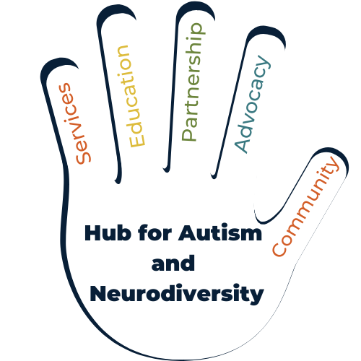

Life today certainly looks different today than it did just a few months ago, especially for individuals with diverse abilities and their families. While we are all finding our own ways to cope and move forward, this may be more challenging for our neurodiverse neighbors than many of us realize.

At the Hub for Autism and Neurodiversity, we hope to make time at home just a little bit easier for parents and family members of individuals with autism - or any diverse ability! Since we can’t host the events we were so looking forward to, we are continuing to promote virtually accessible events and materials on our Facebook Page. We have created a Pinterest Board for fun, simple, activities that shouldn’t require many materials.

We also are available by email at hand@appstate.edu if you need help coming up with activities, support in finding resources, or brainstorming solutions to make this time easier for your loved one. Please reach out if you need support or resources!

