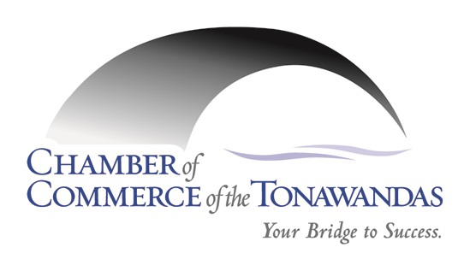
REQUEST FOR PROPOSAL (RFP)

Prepared By: Sarah Nelson
Date: April 13, 2021

Submission Deadline: May 3, 2021
Questions: Questions may be submitted in written form no later than April 26, 2021
Application
Contact Name:

Company Name:

Contact Address:

Telephone:

Email Address:

Our Cost Per Meal Inclusive (the Chamber is not tax except):

Introduction
We “Welcome” our valued Chamber Members to submit a written proposal for our Chamber Exop Box Lunches for Saturday, October 16, 2021

We are looking to provide box lunches/drink to our vendors.
We would like to offer our vendors (3) options, with (1) option being a vegetarian option.
We are asking that they be delivered to the vendors booth at 12:00 noon (time subject to change).
The event is at Gratwick Hose Company, Inc.

Location To Submit The Bid
Chamber of Commerce of the Tonawandas
254 Sweeney Street
North Tonawanda, NY 14120
Or director@the-tonawandas.com
*Attention – Sarah Nelson

Time
12:00 noon- subject to change

Deadline
May 3, 2021. This will ensure that all members have a chance to submit a bid.

We look forward to having you join us on October 14, 2021!
Thank you for your support!

