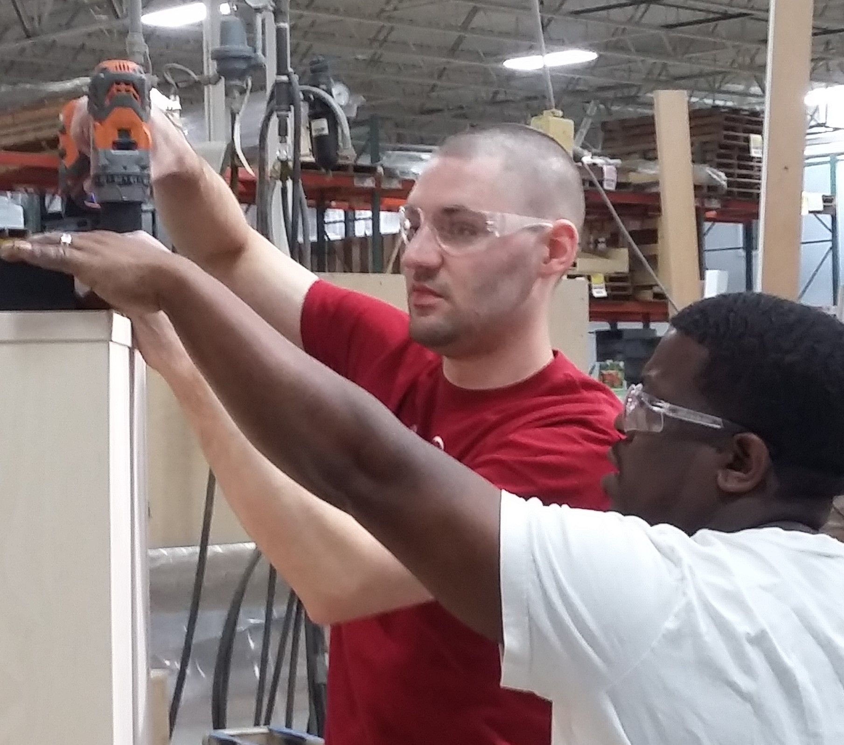  Finding Workforce  SoLutions  A Community Forum & Breakfast  Businesses have workforce needs and people with disabilities have the skills and desire to work.  Join this Community Conversation event to:  - Learn how hiring people with disabilities will improve your bottom line  - Find business solutions and resources to meet your workforce needs  - Make connections with community members interested in solving local workforce issues  - Help our community become more diverse, inclusive and welcoming for people with disabilities  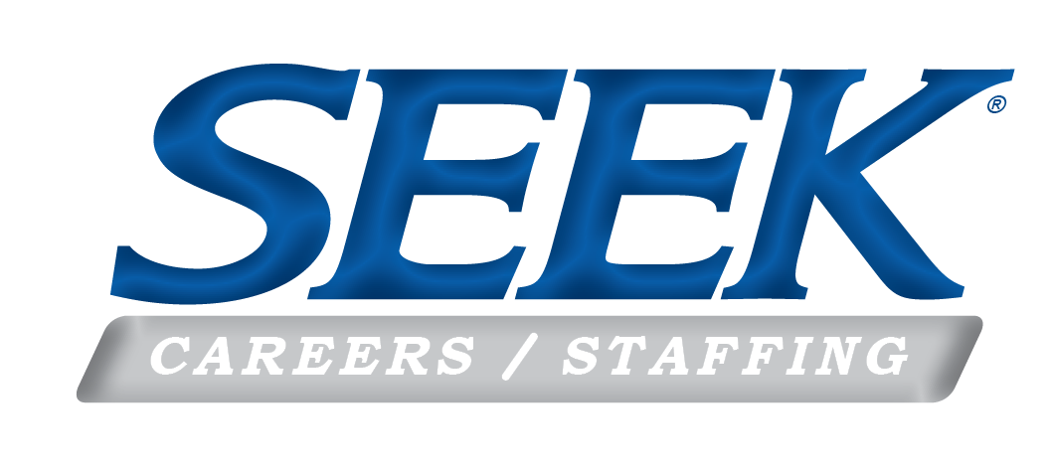  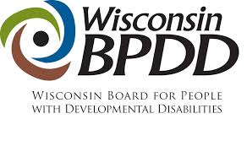 | WHO SHOULD ATTEND?  Employers, elected officials, job seekers with disabilities and their family members, educators, and organizations serving job seekers with disabilities  WHEN:  Thursday, November 14, 2019  7:30am to 9:30am  WHERE:  The River Room on the Milwaukee  1218 13th Ave, Grafton, WI 53024  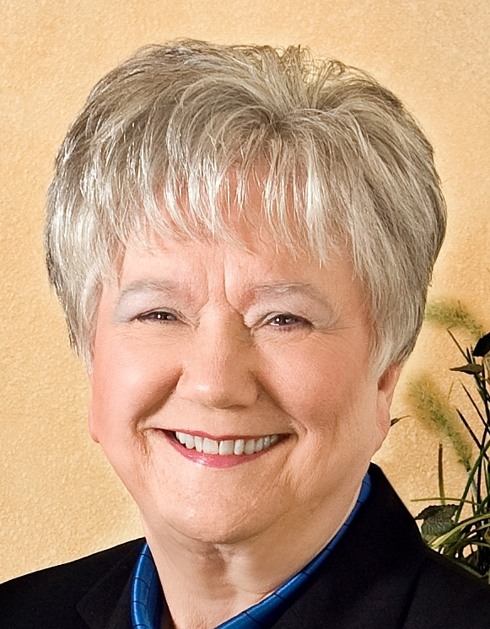  Facilitated by: Carol Ann Schneider, CPC, SPHR, Chief Executive Officer, Founder, and Chair of the Board  AGENDA:  7:30am – 8:00am Complimentary Breakfast  8:00am – 8:30am Guest Panel: Employment Success Stories & Benefits of a Diverse Workforce  8:30am – 9:15am Workforce Resources & Solutions Discussion  9:15am – 9:30am Wrap Up  REGISTRATION INFORMATION:  Online:  http://workforceforumgrafton.splashthat.com  By Email:  shannon@incontrolwisconsin.org  Or Call:  1-608-318-0700  Please RSVP by November 5, 2019

